

Africa Regional Workshop on oil and gas operations in environmentally sensitive areas

Participant Workbook

(insert country and date info here)

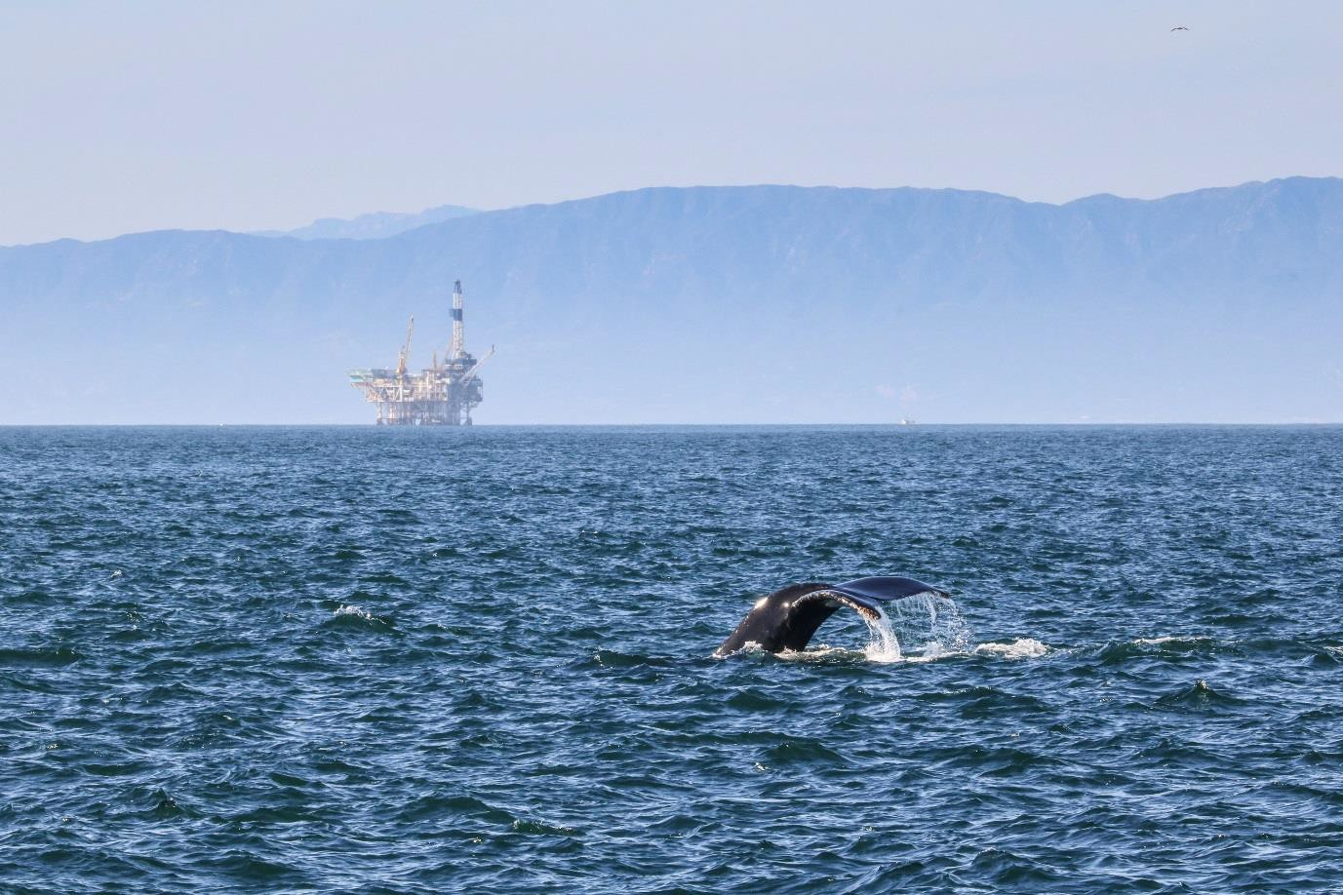

Hosted by:



This publication may be reproduced for educational or non - profit purposes without special permission, provided acknowledgement to the source is made. Reuse of any figures is subject to permission from the original rights holders. No use of this publication may be made for resale or any other commercial purpose without permission in writing from UN Environment. Applications for permission, with a statement of purpose and extent of reproduction, should be sent to the Director, UNEP-WCMC, 219 Huntingdon Road, Cambridge, CB3 0DL, UK.

The contents of this report do not necessarily reflect the views or policies of UN Environment, contributory organisations or editors. The designations employed and the presentations of material in this report do not imply the expression of any opinion whatsoever on the part of UN Environment or contributory organisations, editors or publishers concerning the legal status of any country, territory, city area or its authorities, or concerning the delimitation of its frontiers or boundaries or the designation of its name, frontiers or boundaries. The mention of a commercial entity or product in this publication does not imply endorsement by UN Environment.

This training workshop has been prepared for capacity building only and does not constitute professional advice. The information contained within the workshop material should not be relied upon as a substitute for appropriate technical expertise or professional advice. Nor representation or warranty (express or implied) is given as to the accuracy of completeness of the information contained within it.

To the extent permitted by law, IPIECA, UNEP-WCMC and UN Environment, their members, employees and agents do not accept or assume any liability, responsibility or duty of care for any consequences of you or anyone else acting, or refraining to act, in reliance on the information contained in this capacity building programme or for any decision based on it.

Participant Workbook Copyright 2018 United Nations Environment Programme

**Summary of workshop structure**

|  |  |
| --- | --- |
| **Module** | **Sub-section** |
| **1**  **Impacts and business case for**  **mitigation** | 1.1 Industry overview of the upstream oil and gas sector - understanding impacts and mitigation |
| 1.2 Making the case for biodiversity and ecosystem services in the context of oil and gas |
| **2**  **Planning for oil and gas development** | 2.1 Understanding integrated area-based planning in the context of oil  and gas exploration |
| 2.2 Strategic Environmental Assessments and area-based planning |
| 2.3 Environmental sensitivity mapping in the context of area based  planning |
| 2.4 Cross-sectoral planning and stakeholder engagement |
| 2.5 Tools and demonstrations of area-based planning approaches |
| **Field visit** | |
| **3**  **Biodiversity considerations at the Project Level** | 3.1 An overview of the ESIA process and introduction to the Mitigation  Hierarchy |
| 3.2 Screening for potential biodiversity impacts |
| 3.3 Scoping further assessment of biodiversity and ecosystem services  impacts |
| 3.4 Assessing biodiversity and ecosystem service baselines |
| 3.5 Assessing potential impacts and dependencies on biodiversity and  ecosystem services |
| 3.6 Management and mitigation of impacts and dependencies on  biodiversity and ecosystem services |
| 3.7 Monitoring and verification of company performance |

**Case study presentations**

|  |  |
| --- | --- |
| **Case study title** | **Presenter** |
| How oil and gas operations can impact environmentally sensitive areas | Uganda |
| How oil and gas companies manage biodiversity impacts in sensitive areas | TOTAL |
| Applying SEAs in the oil and gas sector | Mozambique |
| Environmental sensitivity mapping | Tanzania |
| Integrated management plans in the seas – cross-sectoral cooperation, onshore  and offshore examples | Norway |
| Applying EIAs for oil and gas projects | Kenya |
| Assessing potential impacts and environmental sensitivity mapping | Zanzibar |

**Capacity needs and action planning**

Throughout the workshop we will address implications for capacity needs based on the discussion and materials presented, concluding with the development of action plans.

# Contents

Introduction 5

Module overview 7

Module 1: Understanding how oil and gas operations can impact environmentally sensitive areas and making the case for effective mitigation 8

* 1. Industry overview of the upstream oil and gas sector - understanding impacts and mitigation 8
  2. Making the case for biodiversity and ecosystem services in the context of oil and gas 10

Module 2: Integrated area-based planning in the context of oil and gas exploration 13

* 1. Understanding integrated area-based planning in the context of oil and gas exploration 13
  2. Strategic Environmental Assessments (SEAs) and area-based planning 16
  3. Environmental sensitivity mapping in the context of area-based planning 19
  4. Cross-sectoral planning and stakeholder engagement 22
  5. Tools and demonstrations of area-based planning approaches 23

Field visit – Nairobi National Park 24

Module 3: Biodiversity considerations at the Project Level 26

* 1. An overview of the Environmental and Social Impact Assessment (ESIA) process and introduction to the Mitigation Hierarchy 26
  2. Screening 31
  3. Scoping further assessment of biodiversity and ecosystem services impacts 35
  4. Assessing biodiversity and ecosystem service baselines 37
  5. Assessing potential impacts and dependencies on biodiversity and ecosystem services 41
  6. Management and mitigation of impacts and dependencies on biodiversity and ecosystem services 46
  7. Monitoring and verification of company performance 49

Capacity Needs and Action Planning 51

Annex A: References and guiding documents 56

# Introduction

As oil and gas operations move into more challenging and remote locations, we are seeing an increasing level of conflict and trade-offs between development and conservation of the environment and the world’s biodiversity. Recent research has shown that across Africa, 20% of oil and gas contract blocks overlap with protected, conserved and environmentally sensitive areas1. Therefore, there is an urgent need to identify and implement ways of planning for and developing oil and gas resources while safeguarding the natural environment.

Under the Oil for Development Programme (OfD), the Government of Norway and

UN Environment have a 5-year collaboration (2016-2021) to enhance national capacities for improved environmental management in OfD-supported countries with emerging oil and gas sectors. Based on this collaboration, UN Environment together with its biodiversity specialist agency, the UN Environment World Conservation Monitoring Centre (UNEP- WCMC), and IPIECA (the global oil and gas industry association for environmental and social issues), have developed a 5-day course on planning for and managing oil and gas operations in and near protected and environmentally sensitive areas. This course will draw on case study examples and perspectives of different stakeholders, including industry.

# Aim of the course

To enhance understanding of the potential impacts on protected, conserved and environmentally sensitive areas from oil and gas operations, and the management approaches that can support a positive relationship between oil and gas development and social and environmental objectives in and around these areas.

# Learning Objectives

* Increase awareness of the need to manage the impacts of oil and gas development in areas of biodiversity value (including protected, conserved and environmentally sensitive areas) to ensure their values are maintained or enhanced;
* Understand spatial planning approaches to avoid or mitigate impacts from oil and gas development;
* Learn about industry best practices on project-level impact mitigation, drawing on case study examples and guidance materials from leading organisations; and
* Establish how to integrate biodiversity management best practice approaches into the country’s environmental (and social) impact assessment processes.

1 <http://wcmc.io/AfricaOilGas>

# Expected Outputs

* Baseline Evaluation of Participants’ knowledge;
* End-of-Course Evaluation of Participants’ knowledge;
* Training course materials made available to participants, as slide packs with notes and handout materials;
* Group Action Plans for each country of prioritized capacity gaps for strengthening biodiversity management in the oil and gas sector;
* Where relevant, multi-country action plans to address transboundary issues;
* Networking for enhanced national/regional coordination on biodiversity management in the oil and gas sector;
* Cross-country learning on the strategies to manage impacts of oil and gas on biodiversity (for regional training); and
* A refined understanding of the specific capacity needs of each country participating to refine the course for national delivery.

**Write down your personal expectations and what you would like to learn from attending this workshop.**

# Module overview

## Module 1 – Understanding how oil and gas operations can impact environmentally sensitive areas and making the case for effective mitigation

Biodiversity and ecosystems underpin the society in which we live, providing benefits such as water purification, disease control, pollination, fuel and food, and nature based tourism. Oil and gas development can contribute to national economies, but there is a need to ensure that impacts of operations are managed to maintain the country’s natural resource base. The importance of environmental safeguards for protected, conserved and environmentally sensitive areas is recognised by national law and the international community and is reflected in financial standards such as those of the World Bank. Greater awareness and capacity may be needed to ensure national policies are implemented and where necessary strengthened.

## Module 2 – Planning for oil and gas development: an introduction Integrated area-based planning

Early planning of oil and gas development in a country is a crucial first step in mitigating the range of potentially adverse social and environmental outcomes. In any land- or seascape, there are different interests to be addressed, including from local communities, businesses, biodiversity and conservation. The impacts of oil and gas development can amplify existing pressures in a given area. Area-based planning supports the identification of opportunities, risks and trade-offs. As a key driver of human migration to areas and growth in other sectors, the allocation of areas to oil development must be placed in a broader context of changes that will take place across the landscape.

## Module 3 – Introduction to international best practices for the oil and gas sector with regard to protected, conserved and environmentally sensitive areas, and how these can be integrated into the ESIA process

The Environmental, Social Impact Assessment is the basis for managing adverse impacts of oil and gas development on biodiversity and, while the legislation varies from country to country, there are key lessons for integrating elements of industry best practice in its implementation. The oil and gas industry, the finance sector and conservation practitioners have developed approaches and international best practices to mitigate impacts on biodiversity and ecosystem services. These reflect the severity of potential impacts of the sector. This module is developed based on the expertise of the IPIECA Biodiversity and Ecosystem Service Working Group and outputs from the Cross Sector Biodiversity Initiative as well as through expertise gathered by working with leading international companies, financial institutions and conservation organisations.

# Module 1: Understanding how oil and gas operations can impact environmentally sensitive areas and making the case for effective mitigation

This module provides an overview of the oil and gas sector, the upstream oil and gas lifecycle/value chain, how the sector can impact on biodiversity and ecosystem services and the options for mitigation. It also introduces bidoeviersity and ecosystem services concepts, the imporant of protected, conserved and environmentally sensitive areas and the business case for companies to proactively manage their operations to address potential impacts.

## Industry overview of the upstream oil and gas sector - understanding impacts and mitigation

**Contents**

* Context of the oil and gas industry
* Industry value chain and life cycle
* Stages of biodiversity management

**Key messages**

* The global oil and gas industry is a major contributor to economic development
* There will continue to be significant investments to meet global energy demand in the short term
* The biodiversity management approach of the industry begins with avoiding potential impacts, before studying and managing to reduce impacts, and understanding effectiveness of interventions

***Figure 1.*** *The oil and gas value chain, which spans four stages and can be grouped into upstream and downstream activities.*

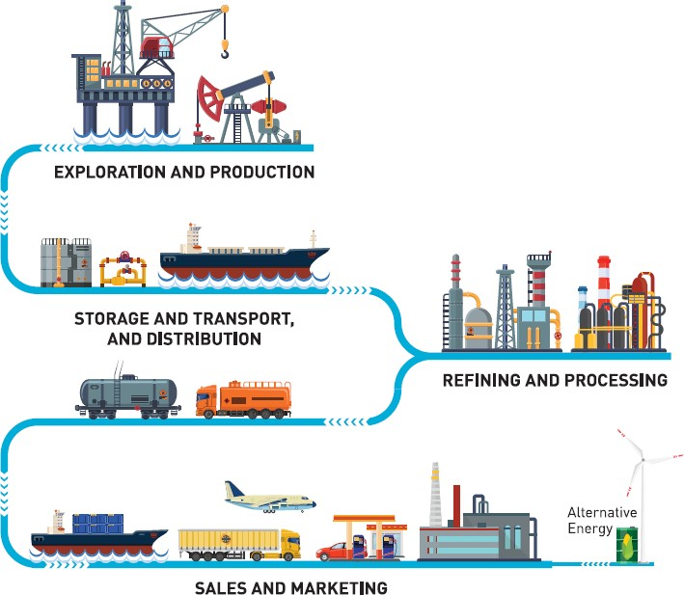

***Figure 2.*** *The upstream life cycle and key biodiversity management stages for the oil and gas industry (Adapted from CSBI, 2015 and Darko, 2014*2*).*

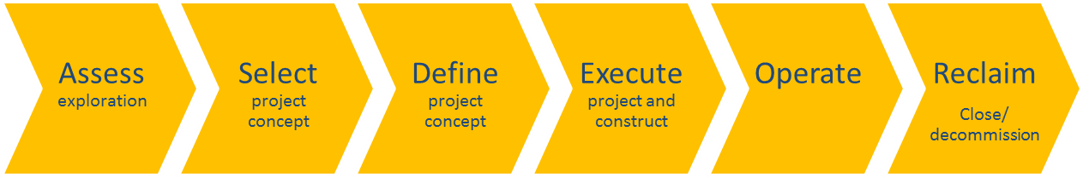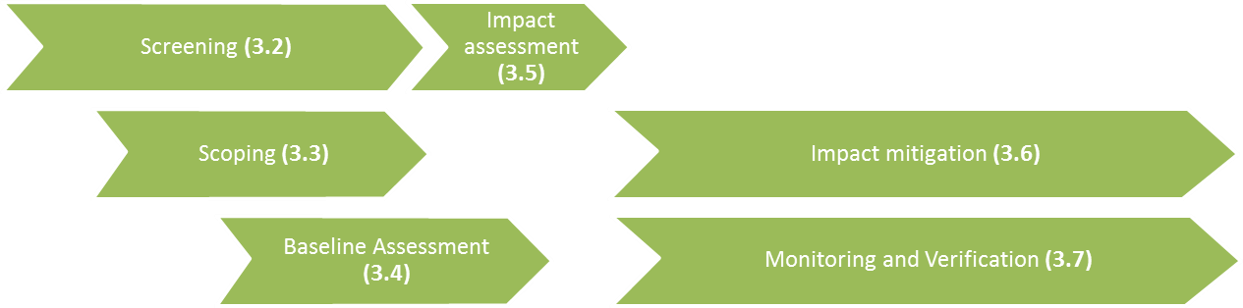

2 CSBI (2015) A cross-sector guide for implementing the Mitigation Hierarchy, and Darko E (2014) Short guide summarising the oil and gas industry lifecycle for a non-technical audience

## Making the case for biodiversity and ecosystem services in the context of oil and gas

**Contents**

•

•

•

•

Basic biodiversity concepts Areas delineated for conservation Linking nature to people

Business case for biodiversity and ecosystem service management

**Key messages**

* Biodiversity forms the basis of ecosystems and underpins ecosystem services
* Protected areas are one of the cornerstones of in situ conservation – but

significant biodiversity values exist outside protected areas

* Key Biodiversity Areas are always identified based on known biodiversity values – many are not protected
* It is essential to understand biodiversity values across a landscape
* There is a robust business case for companies to address biodiversity and ecosystem services impacts and dependencies

*Figure 4. Different levels of biodiversity.*

**Biodiversity:** Biological diversity means the variability among living organisms from all sources including, terrestrial, marine and other aquatic ecosystems; this includes diversity within species, between species and of ecosystems (Convention on Biological Diversity 1992; Figure 4).

**Species:** Groups of actually or potentially interbreeding natural populations, which are reproductively isolated from other such groups (Mayr 1942).

**Species richness:** The number of species within a given sample, community or area (MEA 2005).

**Species range:** The environmental conditions or geographic area within which a species occurs (Oxford Dictionary of Ecology 2010).

**Habitat:** The place or type of site where an organism or population naturally occurs (Convention on Biological Diversity 1992).

**Ecosystem:** A dynamic complex of plant, animal and micro-organism communities and their

non-living environment interacting as a functional unit (Convention on Biological Diversity 1992; Figure 3).

**Ecosystems approach:** “The ecosystem approach is a strategy for the integrated management of land, water and living resources that promotes conservation and sustainable use in an equitable way” (Convention on Biological Diversity 2000).

**Protected area:** “A clearly defined geographical space, recognised, dedicated and managed, through legal or other effective means, to achieve the long-term conservation of nature with associated ecosystem services and cultural values” (IUCN 2008).

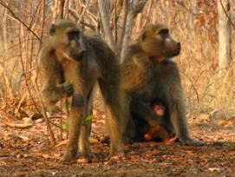

**Genes**

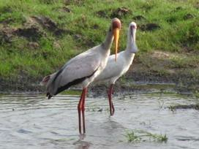

**Species**

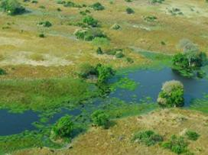

**Ecosystems**

*Figure 3. Four key elements of ecosystems.*

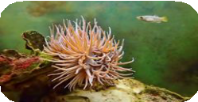

Biotic (living) Abiotic (non- living)

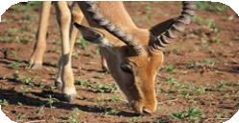 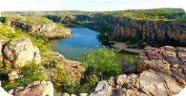

Interactions of energy flows

Physical space

***Figure 5.*** *The link between ecosystem services and people.*

**Key Biodiversity Area:** Sites contributing significantly to the global persistence of biodiversity (IUCN 2016).

**Ecosystem service:** Benefits people obtain from ecosystems (Millennium Ecosystem Assessment 2005; Figure 5).

**Natural Capital:** “The stock of renewable and non-renewable resources that combine to yield a flow of benefits to people” (Natural Capital Protocol 2016).

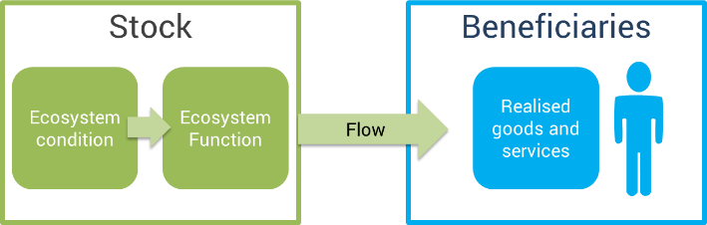

***Figure 6.*** *Major drivers of changes in biodiversity and their effects.*

***Figure 7.*** *Major external drivers for business to manage biodiversity and ecosystem services.*

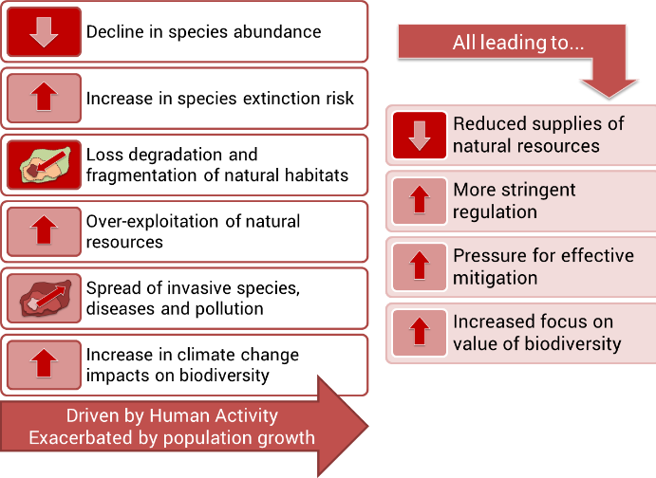 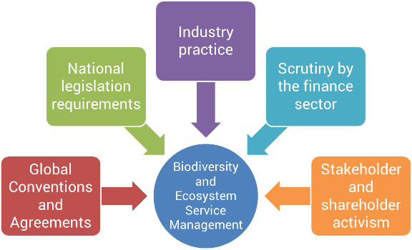

# Module 2: Integrated area-based planning in the context of oil and gas exploration

The aim of this module is to demonstrate how integrated area-based planning can offer opportunities to proactively coordinate sustainable development with conservation objectives. Integrated area-based planning is referred to in many ways, but commonly uses spatially explicit, participatory methods to identify where to allocate activities in order to maximize social, economic and ecological objectives. For the oil and gas sector, proactive planning can help not only to avoid or minimise significant impacts, but also to identify suitable areas for restoration or aggregated offsets to compensate for impacts, advancing progress toward a policy of no net loss or net gain of biodiversity.

## Understanding integrated area-based planning in the context of oil and gas exploration

**Contents**

* What is integrated area-based planning?
* What are the common principles of integrated area-based planning in the context of oil and gas exploration?
* Why should we map biodiversity and ecosystem services?

**Key messages**

* National integrated area-based planning offers an opportunity **to proactively define how resources can be used sustainably**, supporting **progress toward multiple national and international targets with synergistic outcomes**;
* Common principles include:
  + Spatial data as the underpinning framework;
  + Importance of cross-sectoral stakeholder engagement in understanding different values and trade-offs; and
  + Use of multiple tools to inform area-based plans, including GIS and valuation tools.
* Mapping biodiversity and ecosystem services is important to **inform planning toward enhancing multiple social, economic, environmental and cultural benefits** within a particular area.

***Figure 8:*** *Integrated area-based planning is a process through which management regulations of human activities, such as oil and gas exploration, are designed for a defined spatial area. This can take into account many different features and activities, as demonstrated by the legend below.*

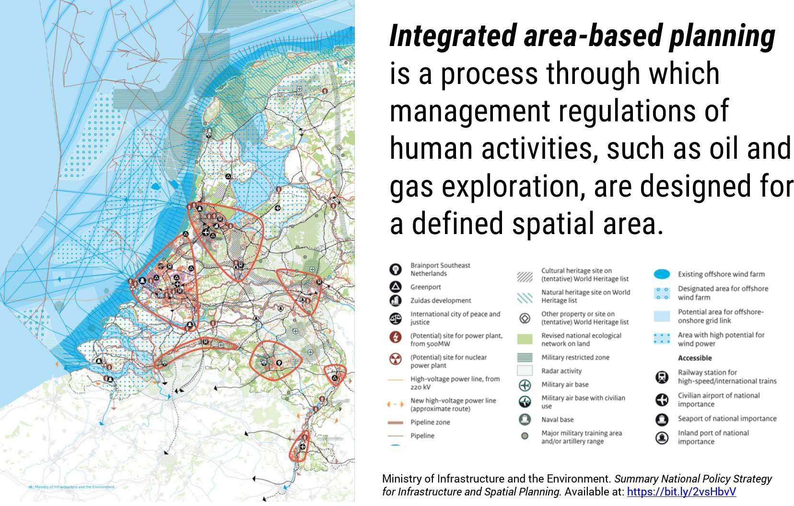

***Figure 9:*** *Integrated area-based planning takes into account the holistic relationships between the environment, the economy and society in order to develop spatial plans that maximize benefits. This diagram demonstrates the relationships within the Sustainable Development Goals, and how society and the economy are underpinned by the biosphere*

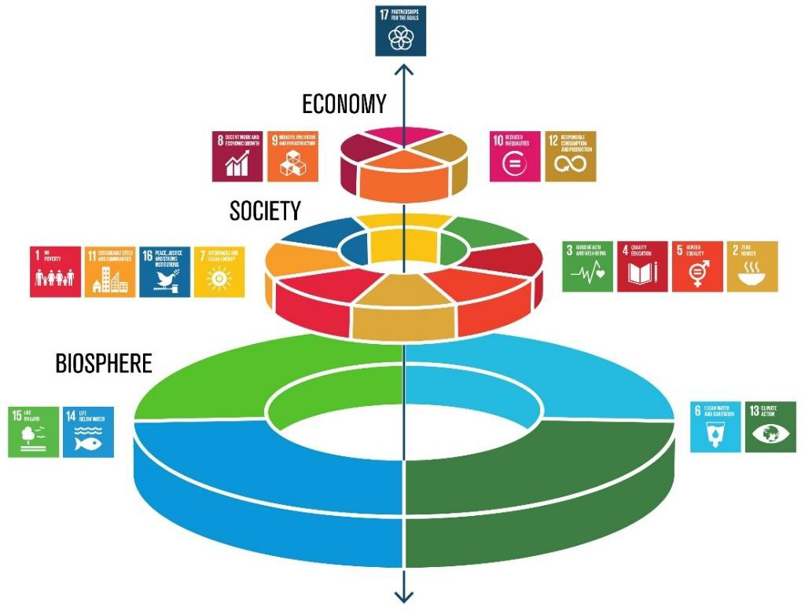

***Figure 10:*** *In Panama, REDD+ was used to assess how activities could be used to enhance the number of benefits derived beyond mitigation. This approach could be equally applied in the context of oil and gas development, reviewing opportunities to avoid or minimize impacts.*

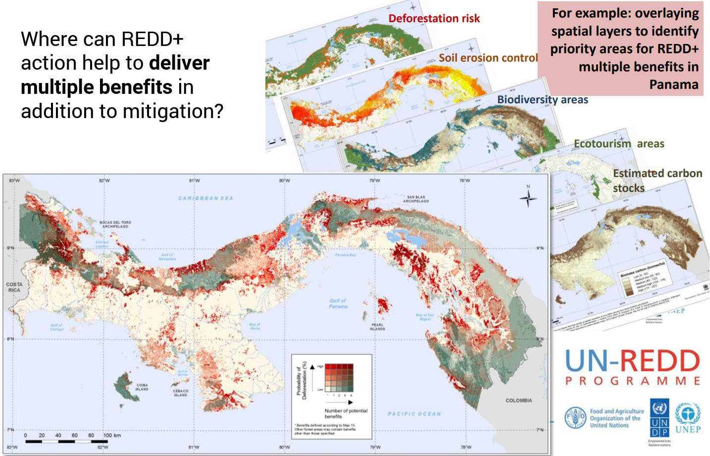

## Strategic Environmental Assessments (SEAs) and area-based planning

**Contents**

•

•

•

•

•

•

•

What is a Strategic Environmental Assessment? Relationship between SEAs and EIAs?

Legislative developments

The Mitigation Hierarchy and SEAs

What is the current status of SEAs in your countries? Relationship between SEAs and area-based planning Case study: SEAs in the oil and gas sector in Mozambique

**Key messages**

* Strategic Environmental Assessments (SEAs) **integrate environmental, economic and social elements** and are applied to policies, plans and programs.
* There is increasing uptake of SEA legislation and practice.
* SEAs can be **effective when tiered to the Environmental Impact Assessment (EIA) process.**
* **Adopting the mitigation hierarchy as part of the SEA** is considered good practice.
* SEAs can support integrated area-based planning.

Strategic Environmental Assessments (SEAs) represent a systematic approach for mainstreaming and upstreaming environmental sensitivity into decision-making. SEAs occur earlier in the decision-making process than Environmental Impacts Assessments (EIAs), and can **make the planning process more efficient, narrow the scope of EIAs, and capture cumulative effects (Figure 9)**.

SEAs support area-based planning processes by ensuring the integration of environmental, economic and social considerations through broad stakeholder engagement. Maps of environmental sensitivity therefore form key inputs to SEAs (see **Section 2.3**).

***Figure 11.*** *Relationship between Strategic Environmental Assessments (SEAs) and Environmental Impact Assessments (EIAs) (UNECE, 2017).*

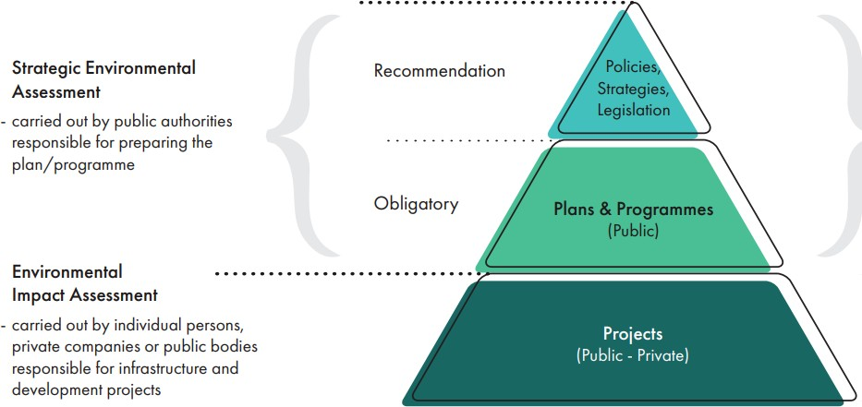

***Figure 12.*** *Strategic Environmental Assessment (SEA) is being increasingly implemented within countries (approximately 40 now have SEA regulations). This diagram illustrates the SEA workflow (UNECE, 2017), which can effectively align with broader, multi-sectoral integrated area-based planning processes and can inform subsequent Environmental Impact Assessment processes.*

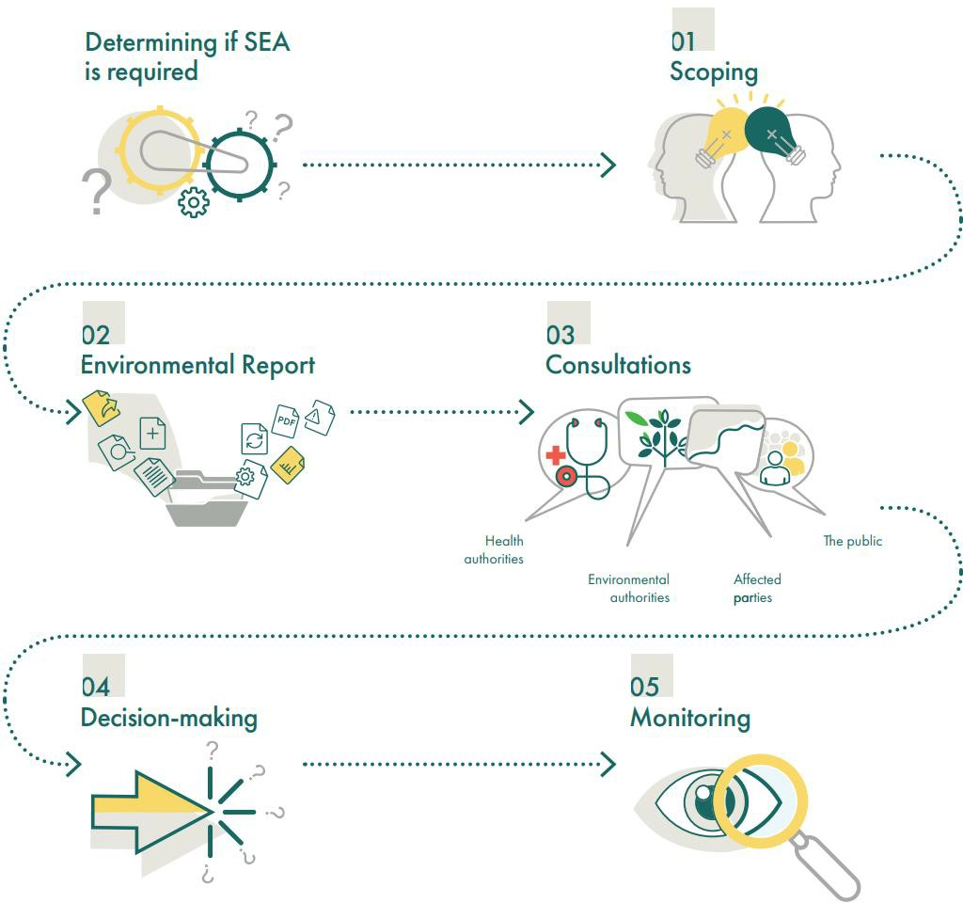

***Figure 13.*** *Consideration of the mitigation hierarchy in Strategic Environmental Assessments can help to ensure that strategic-level planning identifies greater opportunities to avoid impacts through alternatives, such as aggregated offsets.*

+

Biodiversity value

-

Predicted impact Offset

Restore Minimise Avoid

## Environmental sensitivity mapping in the context of area-based planning

**Contents**

•

•

•

•

•

What is Environmental Sensitivity Mapping? Workflow and types of sensitivity maps Examples of methods used internationally Benefits of environmental sensitivity maps

Case study: Environmental sensitivity mapping in Tanzania

**Key messages**

* Environmental sensitivity mapping can **form one component of a larger, integrated area-based planning process**, **while also informing other activities (e.g. national oil spill contingency plans).**
* Maps can **range from simple, spatially-explicit indexes of sensitive ecosystems to more complex maps depicting the sensitivity of species, ecosystems and socio-economic or cultural human activities**, as well as the value attributed to these activities.
* Can be **strengthened through stakeholder consultation and integration of local or traditional knowledge**, also contributing to a larger, area-based planning process determining the spatial allocation of activities.

# Methods for sensitivity mapping

### Definitions

***‘Vulnerability’*** is a function of *exposure*, *sensitivity* and *adaptive capacity,* where*:*

***‘Sensitivity’*** refers to the characteristics that describe the state of the system, and the degree to which this system will respond to a pressure.

***‘Exposure’*** quantifies the intensity or severity of this pressure, and the likelihood of occurrence.

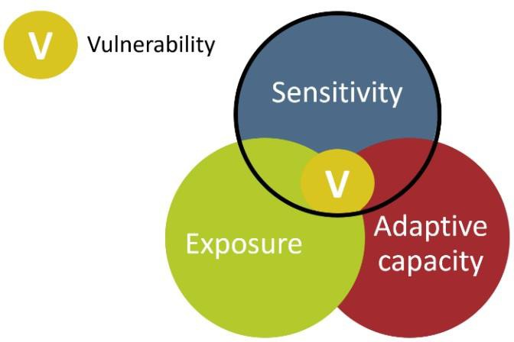

***Figure 14.*** Diagram illustrating the relationship between vulnerability, sensitivity, exposure and adaptive capacity.

***‘Adaptive capacity’*** involves measuring the species’, habitat’s, or ecosystem’s ability to cope with the impacts of this pressure.

***Figure 15.*** *Workflow for environmental sensitivity mapping.*

1. Assess need(s) 2. List priorities 3. Identify available



datasets

* + 1. Create asset map
    2. Assess pressures
    3. Sensitivity scoring (Environmental

Sensitivity Index, or ESI)

* + 1. Singular or aggregated ESI across

multiple pressures

* + 1. Operationalise sensitivity map

***Figure 16.*** *Characteristics of environmental sensitivity maps, as demonstrated by the Coastal Sensitivity Atlas of Mauritius.*

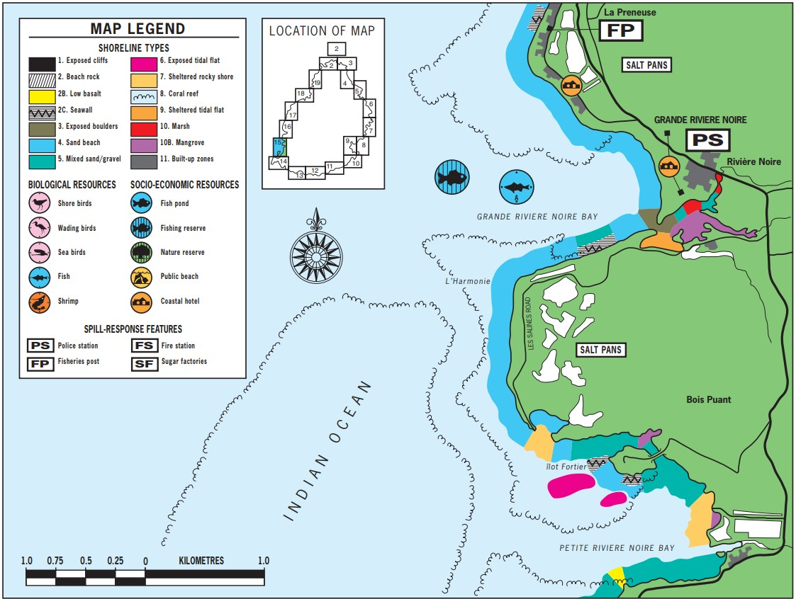

# Map-based exercise on integrated area-based planning

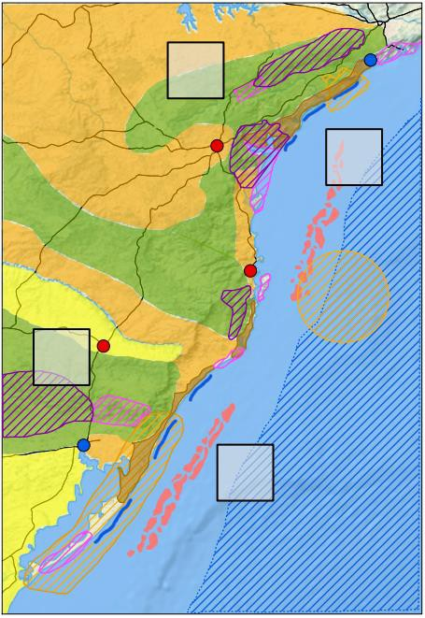**Instructions:**

New onshore and offshore concession blocks have been identified in a country of interest, yet the country has considerable terrestrial and marine biodiversity and thriving socio-economic sectors (e.g. tourism), with high population densities along the coastline.

In groups of four to five, evaluate the following:

* + - * **What are the potential environmental and social impacts** to consider for each of the proposed concession blocks?
      * **Which concession blocks would you choose,** and why? What are the main trade- offs?

### What other information might be useful?

* + - * Where might be good sites for **new protected areas or aggregated offsets?**

Please prepare to present your selection and answers to the above questions following the break.

**Notes:**

## Cross-sectoral planning and stakeholder engagement

**Contents**

•

•

•

•

Characteristics of multi-sectoral planning?

Who are the stakeholders, and how do they contribute to the integrated area- based planning process?

What are the benefits and challenges associated with stakeholder participation?

Case study: “Integrated management planning in the sea” (Norway)

**Key messages**

* Stakeholder engagement is an **essential component of the integrated area- based planning process.**
  + Important to understand different values and priorities, and to **strengthen long-term support for planning process;**
  + **Minimises conflict** among stakeholders;
  + **Maximises beneficial, equitable and representative socio-economic, cultural and biodiversity outcomes.**
* Contributes towards multiple Sustainable Development Goals and Targets.

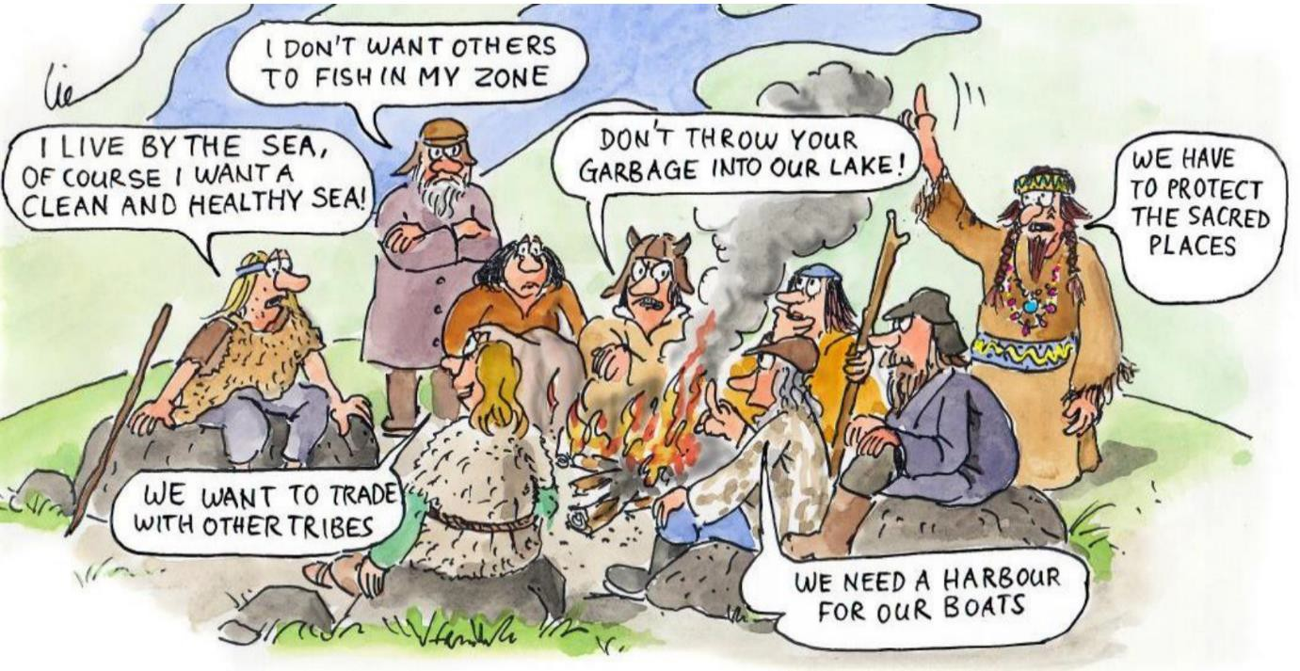

A **stakeholder** is “an individual, group or organization who has an interest (or a ‘stake’), or who can affect or is affected, positively or negatively, by a process or management decision.”

***Figure 17.*** *Stakeholder engagement cycle (IOGP, 2014).*

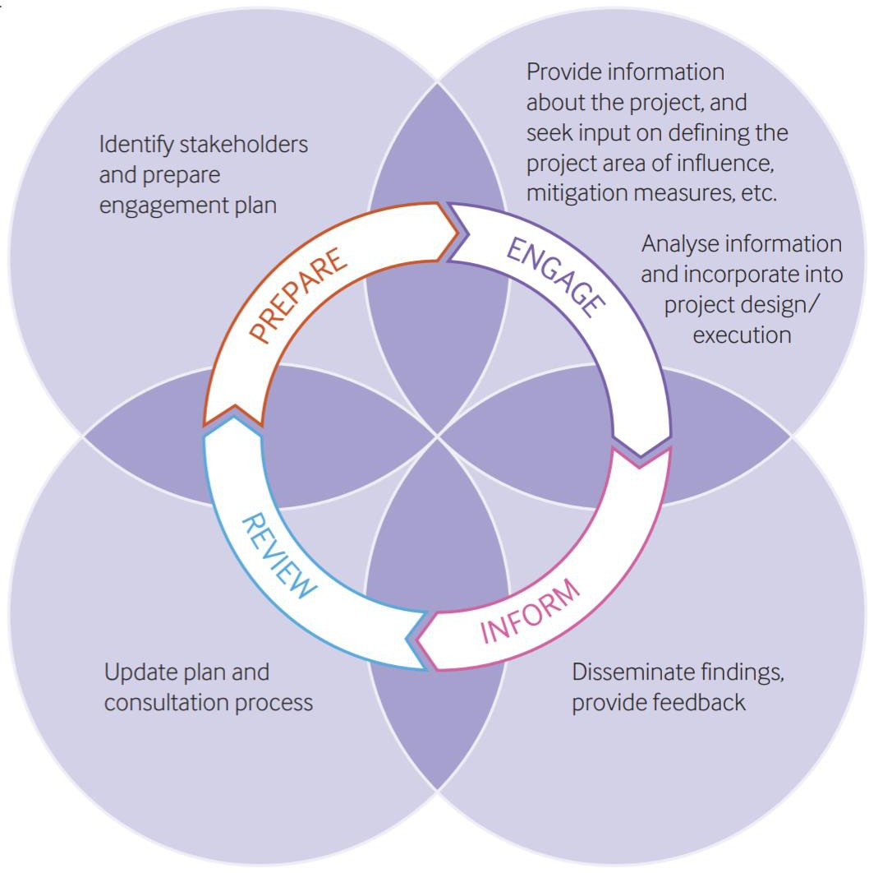

***Figure 18.*** *Stakeholder mapping analysis, illustrating how to engage with stakeholders based of level of influence and interest (Adapted from Eden and Ackermann, 1998).*

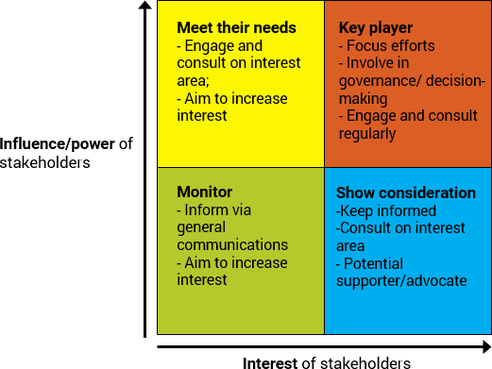

## Tools and demonstrations of area-based planning approaches

We will introduce a few tools using a ‘world café’ format, where groups rotate tables every 10 minutes.

**Field visit – Nairobi National Park**

# Instructions

Working in four mixed country teams, imagine that oil has been discovered in the location surrounding this protected area. In this scenario, the size and precise location of the reserve is not yet proven. In order to plan for an eventuality where the reserve proves to be economically viable, we would like you to consider the future implications.

Each group will address a different stage of the oil and gas upstream value chain:

* **Exploration and appraisal** (seismic activity and drilling test wells)
* **Development** (design and construction of production facilities and infrastructure)
* **Production** (consider primary and secondary production)
* **Decommissioning** (removal of facilities and infrastructure)

Each group will then consider the following questions. You are encouraged to ask the park/tour operator general questions about the Nairobi National Park that will allow you to reflect on and respond to these questions.

### Who are the main stakeholders that influence and are interested in the biodiversity and ecosystem services provided by the park?

Map the stakeholders according to their level of **interest** (e.g. how much they depend on the biodiversity and ecosystem services) and by their level of **influence** (e.g. how much they control or are responsible for management of the park or activities surrounding it).

Influence

High

|  |  |
| --- | --- |
|  |  |
|  |  |

Low High

Low

Interest

1. **What are the considerations oil and gas development in the park might bring?**

|  |  |
| --- | --- |
| **Which biodiversity and ecosystem service values would be most affected by this stage of oil and gas activity?** |  |
| **What are the potential impacts on biodiversity and ecosystem services of this stage of oil and gas activity?** |  |
| **What trade-offs do you foresee in managing these impacts?** |  |
| **What additional infrastructure or local development may be needed for this stage of oil and gas activity and how might this also impact on the biodiversity and ecosystem services values?** |  |
| **In your country, how have you aimed to avoid and minimize these impacts?** |  |

# Module 3: Biodiversity considerations at the Project Level

An introduction to international best practices for the oil and gas sector with regard to protected, conserved and environmentally sensitive areas, and how these can be integrated into the ESIA process.

## An overview of the Environmental and Social Impact Assessment (ESIA) process and introduction to the Mitigation Hierarchy

**Contents**

•

•

•

•

The Legal ESIA process and global developments Introduction to the Mitigation Hierarchy

Why should companies use the Mitigation Hierarchy?

How do companies apply the Mitigation Hierarchy?

**Key messages**

* The ESIA process is the key legal tool for project level impact assessment and mitigation
* The Mitigation Hierarchy (MH) is a best practice tool to limit negative impacts that should be considered at all stages of a project
* The MH follows an order of preference – Avoid as far as possible, then minimise remaining impacts, then plan to restore, and finally offset any residual impacts
* The MH is iterative and should be used throughout the design and

implementation of a project

* The MH applies to both biodiversity and ecosystem services

# Definition: Environmental and Social Impact Assessment (ESIA) Process

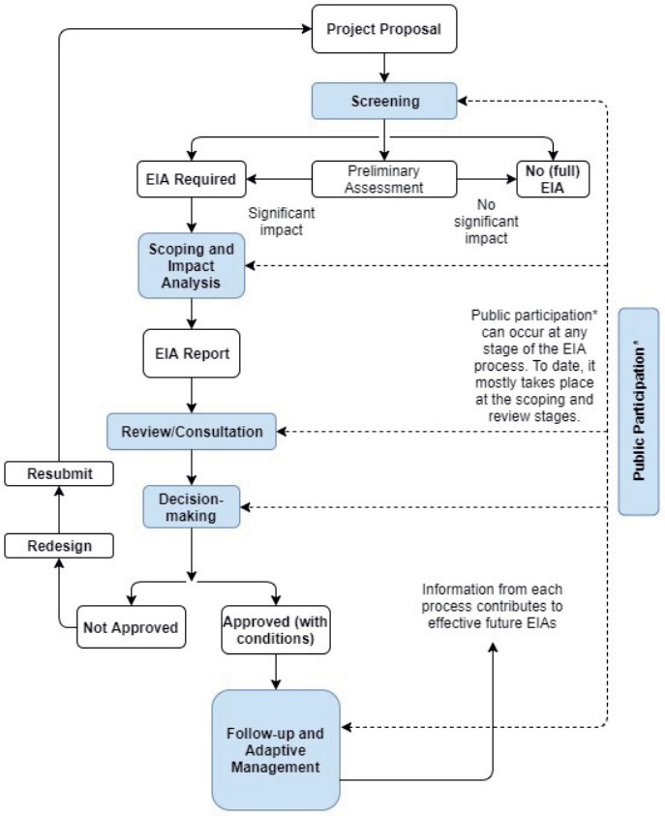

**The ESIA process:** “A systematic process that ensures that environmental, social and economic considerations are incorporated in sound and well- balanced decision making around specific projects”.

**The process varies based on:**

* Division of competencies (sectoral and environmental)
* Degree of consultation at different stages
* Role of public participation
* Content requirements
* Consideration of alternatives
* Consideration of cumulative impacts

***Figure 19.*** *Recent developments in global ESIA legislation.*

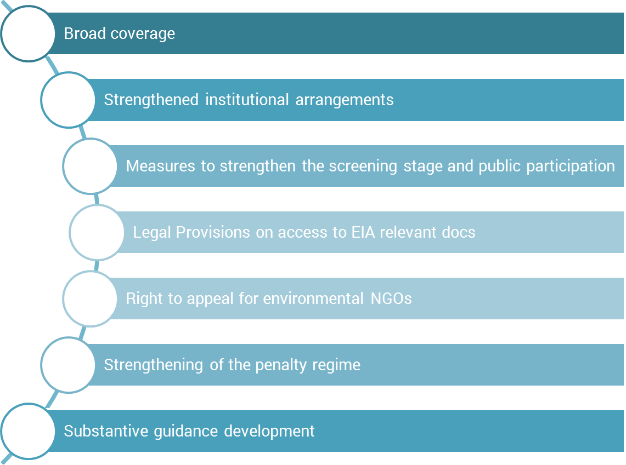

***Figure 20.*** *The relationship between upstream project life cycle and impact assessment and the ESIA process.*

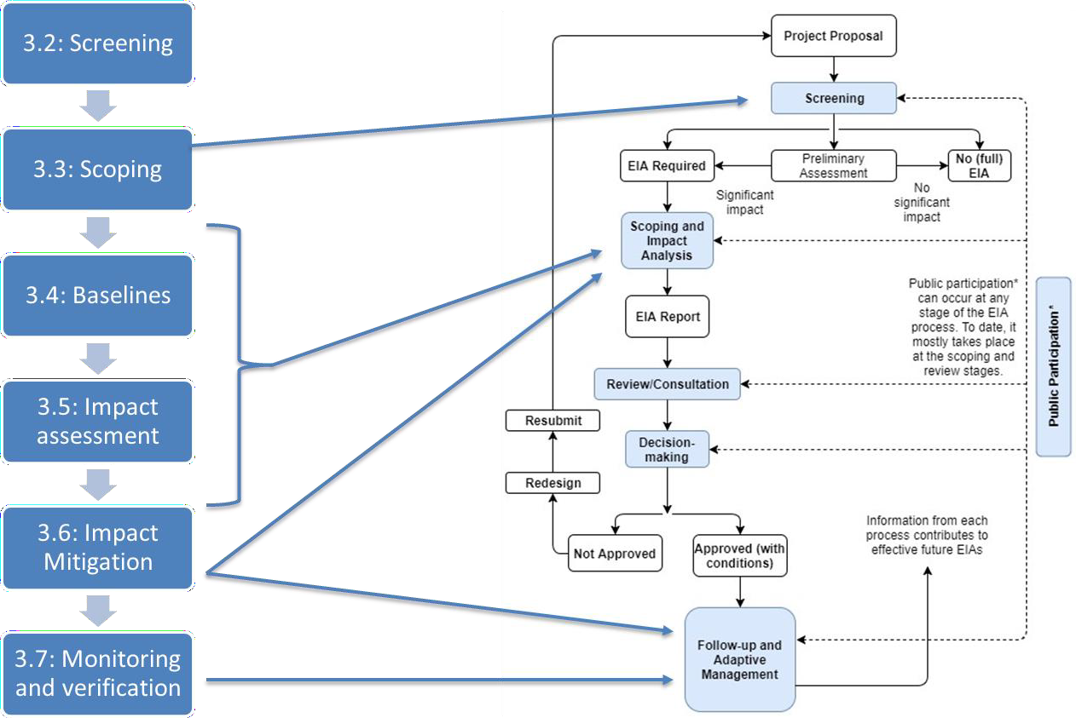

# Definition: Mitigation Hierarchy

+

**The Mitigation Hierarchy:** the sequence of actions used to…

* Anticipate and **avoid**,
* Where not possible, **minimize**,
* When impacts occur, rehabilitate or **restore**,
* Where significant residual impacts remain, **compensate/offset**

… for biodiversity-related risks and impacts to affected communities and the environment (CSBI 2015).

Biodiversity value

-

Predicted impact Offset

Restore Minimise

Avoid

***Figure 21.*** *Definition of the steps in the Mitigation Hierarchy.*

Avoidance

* Measures taken to **anticipate and prevent adverse** impacts on biodiversity before actions or decisions are taken that could lead to such impacts.

Minimisation

* Measures taken to **reduce the duration, intensity, significance and/or extent** of impacts that cannot be completely avoided,

Restoration

Offset

* Measurable conservation outcomes, resulting from actions applied to areas not impacted by the project, that **compensate for significant**, adverse project impacts in order to **achieve no net loss or a net gain** of biodiversity
* Measures taken to **repair, remedy, remediate** habitats, biodiversity values, and/or ecosystem services by revegetating and/or otherwise upgrading degraded or damaged ecosystems.

# Definition: No Net Loss and Net Gain

**No net loss:** “The point at which project-related impacts on biodiversity are balanced by measures taken to avoid and minimize the project’s impacts, to undertake on-site restoration and finally to offset significant residual impacts...” (IFC 2012).

**Net gain:** “Additional conservation outcomes that can be achieved for the biodiversity values for which the critical habitat was designated. They can be achieved through the development of a biodiversity offset or implementation of programs… to enhance habitat, and protect and conserve biodiversity” (IFC 2012).

**Figure 22.** How the Mitigation Hierarchy is implemented throughout the project cycle (Adapted from CSBI 2015).

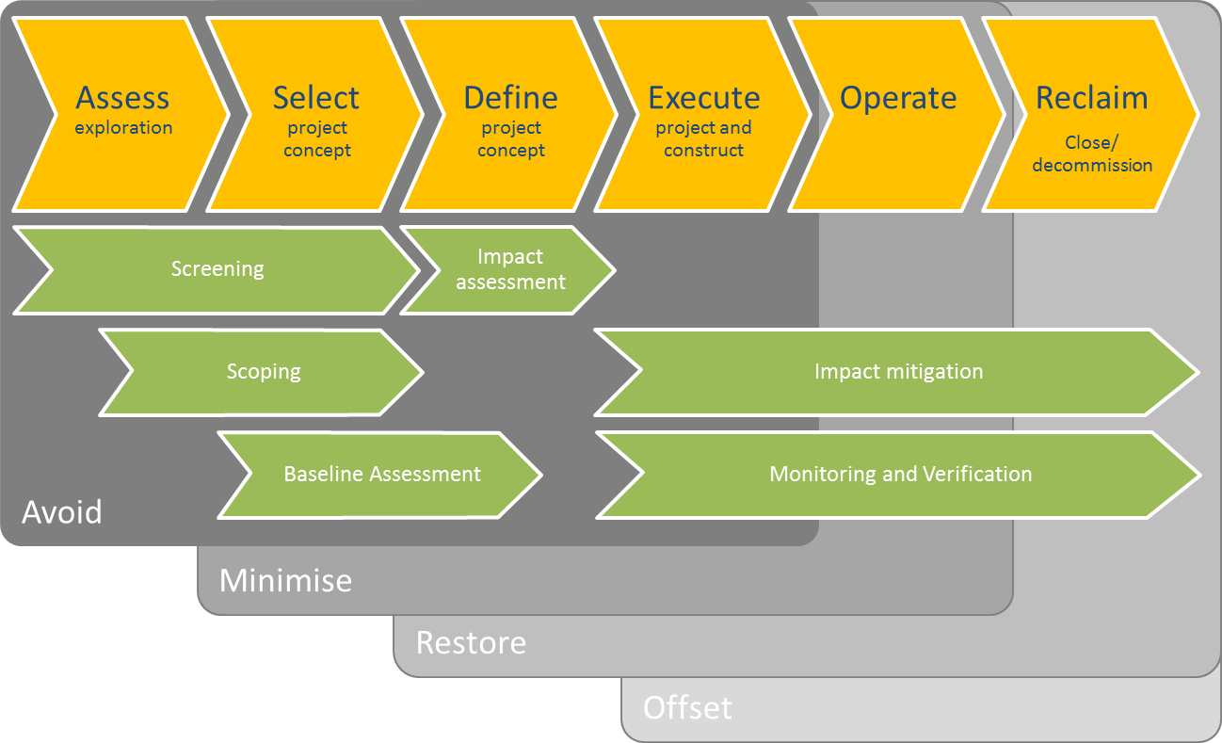

## Screening

**Contents**

•

•

•

•

What is screening? Why is it important?

How do companies screen?

What are the implications for regulators?

**Key messages**

* Screening is the high-level assessment of the potential impacts of different project alternatives
* Screening is central to the first and most important step in the Mitigation Hierarchy: Avoidance
* Screening should take place prior to the selection of the preferred project options
* Screening is usually desk-based, but can still take advantage of reliable guidelines, tools, data and information

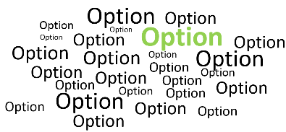

**Why is screening important?**

* It eliminates alternatives with the least manageable impacts and identifies information gaps
* It is the most important opportunity for a project to ‘avoid’ impacts altogether (as part of the Mitigation Hierarchy)
* It is cost-effective and helps avoid expensive ‘surprises’ in later stages of the project cycle

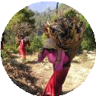

**What do companies screen?**

Protected areas

Threatened species

Sensitive habitats Priority ecosystem

services

# Introduction to hypothetical case study exercise

**Scenario**

Today’s case study builds on the work we did on Day 2. You will now work on the block that you selected in your groups.

Put yourselves in the position of an oil and gas company. You are planning activities in a new oil and gas exploration block. You know that any oil and gas concession will require:

* A production platform;
* A pipeline;
* A processing plant;
* Access roads; and
* A product pipeline to reach their market.

Your geologists and engineers have identified **three** platform options, and **four** onshore processing plant options.

### The following environmental and socio-economic features have been identified within the landscape/seascape.

**Habitats**

* + - Scrubland, which local communities use for grazing livestock
    - Agricultural land
    - Subsistence agriculture in the part of the scrubland area
    - Forest, seemingly undisturbed, covering a large portion of inland area
    - Mangroves present along much of the coastal area
    - Coral reefs situated near the coast
    - Seagrass meadows close to the mangroves
    - Beaches

### Socio-economic features

* + - One marine and one coastal protected area
    - Several Key Biodiversity Areas
    - Several areas dedicated to tourism, an important source of income for locals
    - Offshore commercial fishing areas
    - Cities and an existing port location
    - Small villages inland and along the coast
    - Small coastal communities carry out artisanal fishing in the local area, supported by a small fleet of boats, fishing shacks and boat launches

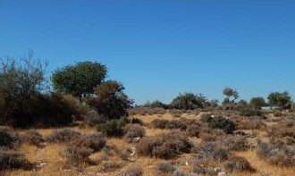 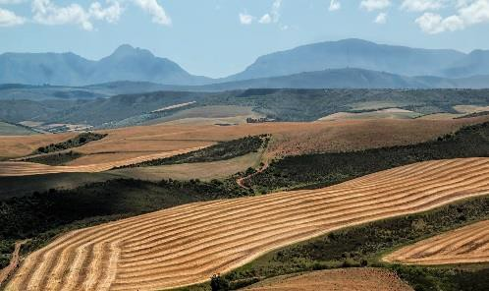 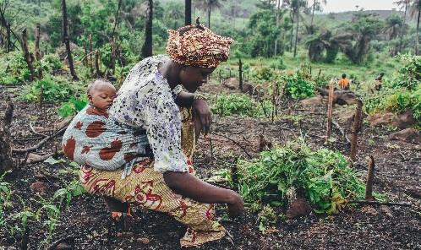

Scrubland

Agricultural land Subsistence agriculture

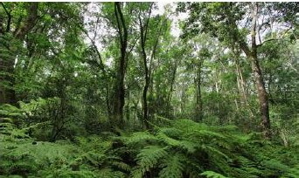 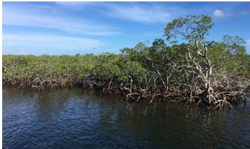 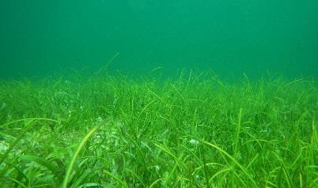

Forest Mangroves Seagrass

Dugong Seagrass on Flickr under CC BY-NC

2.0

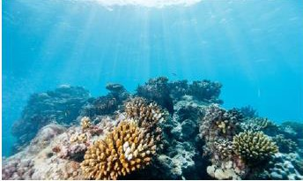 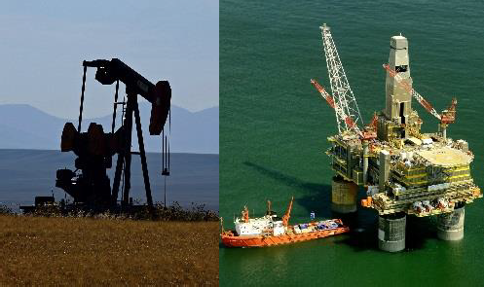 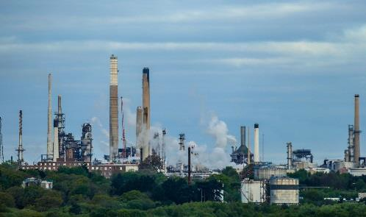

Coral reefs



Beaches

Potential drilling

platforms

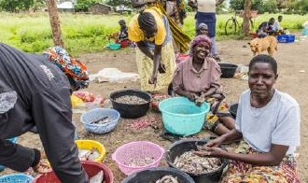

Villages

Processing plants

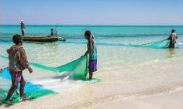

Artisanal fishing

# Exercise 1: Screening

**Aim**

*Understand the context of operations to eliminate potential locations to avoid impacts.*

1. Which platform and processing plant locations might be screened out? Why?
2. Use the table to cross out unsuitable options and tick the suitable option(s).

|  |  |  |  |
| --- | --- | --- | --- |
|  | **Biodiversity and ecosystem services considerations** | | **Is this a potential option?**   * /**** |
| **Sensitivities** | **Implications** |
| *e.g. the site may impact nearby human settlements* | *e.g. delays in operations due to stakeholder discontent over local*  *disruption* |
| **Platform** | | | |
|  |  |  |  |
|  |  |  |  |
|  |  |  |  |
| **Processing plant** | | | |
|  |  |  |  |
|  |  |  |  |
|  |  |  |  |
|  |  |  |  |

## Scoping further assessment of biodiversity and ecosystem services impacts

**Contents**

•

•

•

•

What is scoping? Why is it important?

How do companies carry out scoping?

What are the outputs of good scoping?

**Key messages**

* Scoping determines the priority issues to be considered in the ESIA
* Good scoping helps inform good ESIAs and saves time, money and effort
* Scoping builds on screening to inform baselines

**What is scoping?**

* **Scoping** is different to **screening**
* **Screening** eliminates high-risk project alternatives and identifies key risks and impacts of projects
* **Scoping** identifies and prioritises impacts that warrant further attention

**Why is scoping needed?**

It is a cost-effective way of determining:

* Issues to focus on
* Identifying knowledge gaps
* The scope and boundaries of baseline surveys
* Key stakeholder concerns and support

**How do companies carry out scoping?** They build on screening by:

* + - Reviewing documents, information and maps
    - Conduct rapid site assessments
    - Meeting with key stakeholders
    - Discuss key issues with regulators
    - Consider the wider temporal and spatial context
    - Involve appropriate experts
    - Consider the Mitigation Hierarchy

**What are the outputs of good scoping?** Good scoping should:

* + - * Produce ESIA reports which are targeted and actionable
      * Make the ESIA process more efficient for companies
    - Make the ESIA review process more efficient for regulators
    - Support a more robust baseline

# Exercise 2: Scoping

**Aim:** *Determine the priority biodiversity and ecosystem service features for further study.* Screening was used to potentially eliminate certain onshore sites and offshore platforms. Scoping will now identify the highest priority issues to study among those

identified during screening.

1. List the biodiversity components and ecosystem services you identified in the screening exercise.
2. Note reasons for importance/prioritisation.

|  |  |
| --- | --- |
| **Biodiversity component or**  **ecosystem service** | **Reasons for importance/prioritisation** |
| *e.g. local subsistence fishery*  *(provisioning services)* | *e.g. fish is the only source of protein in this area* |
|  |  |
|  |  |
|  |  |
|  |  |
|  |  |

## Assessing biodiversity and ecosystem service baselines

**Contents**

•

•

•

•

What is a baseline?

Why is a robust baseline important?

How should a baseline be developed and what should it contain? How does a baseline inform future action?

**Key messages**

* Baseline assessments help establish the biodiversity and ecosystem service status before operations begin
* Baseline assessments characterise the existing conditions (conditions may be dynamic and variable)
* Baseline assessments inform impact assessment and management planning, monitoring and adaptive management over the life of the project
* The baseline assessments are essential as a means against which to check performance

# Definitions: Baseline and baseline study

**Baseline:** “A description of existing conditions to provide a reference (e.g. pre-project condition of biodiversity) against which comparisons can be made (e.g. post-impact condition of biodiversity), allowing the change to be quantified.” Biodiversity A-Z terms (website)



**Baseline study:** “Work done to collect and interpret information on the condition/trends of the existing environment.” Biodiversity A-Z terms (website)

***Figure 23.*** *Key good practice steps for collecting biodiversity baseline data (CSBI 2015).*

Identify the biodiversity baseline study area (area of influence)

Identify the scope of the baseline study – what is, or is not, included?

Review existing information on the biodiversity values

Conduct field- based assessment of biodiversity values (if necessary)

Integrate the data into a baseline report

Engage stakeholders and experts

**Figure 24.** Area of influence for different impacts across a landscape

Outside the Area of Influence

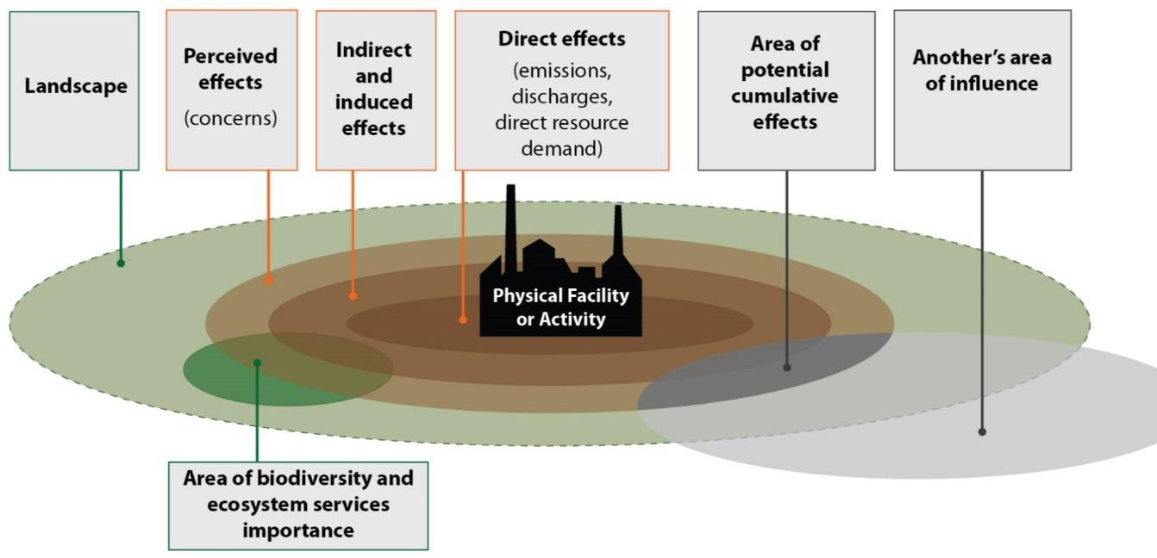

**Legend**

Describes Area of Influence

**Direct effects** (emissions, discharges, direct resource demand)

**Indirect and induced effects**

**Perceived effects** (concerns)

Biodiversity baseline study areas

**Area of potential cumulative effects**

***Figure 25.*** *Figure illustrating the complexity of baselines, which need to account for species’ seasonality.*

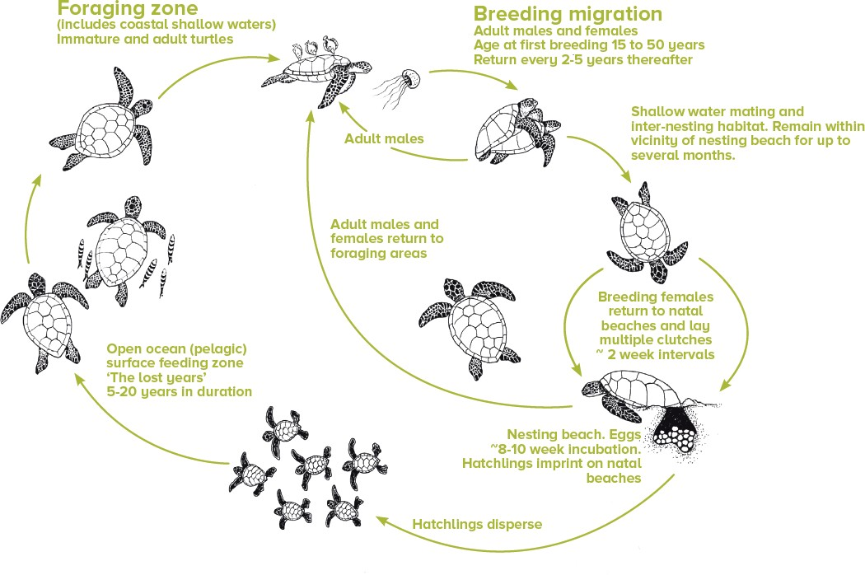

# Exercise 3: Baselines

**Aim:** *Identify the Area of Influence and specific surveys that will assist in establishing the existing biodiversity and ecosystem service status.*

1. What surveys might address your highest-priority biodiversity components or ecosystem services impacts?
2. How should these surveys be scoped to address the project Area of Influence (AOI)?
3. What timing issues should any baseline surveys factor in?

|  |  |  |  |
| --- | --- | --- | --- |
| **Biodiversity component or**  **ecosystem service** | **Type of survey** | **Area of Influence** | **Timing considerations** |
| *e.g. local subsistence fishery*  *(provisioning services)* | *e.g. quantitative baseline fish survey*  *e.g. qualitative local community survey* | *e.g. the whole bay*  *e.g. local community within 10 km radius* | *e.g. minimum two surveys – for both the quantitative and qualitative data to capture seasonality and potential changing*  *perception* |
|  |  |  |  |
|  |  |  |  |
|  |  |  |  |
|  |  |  |  |
|  |  |  |  |

## Assessing potential impacts and dependencies on biodiversity and ecosystem services

**Contents**

•

•

•

What potential impacts and dependencies should be considered? How do companies assess impacts and dependence?

How does this inform future actions?

**Key messages**

* Consider direct, indirect / induced and cumulative impacts a project might have on the environment
* Indirect, induced and cumulative impact mitigation requires a collaborative approach
* Impacts and dependencies should be considered in the context of the wider

landscape and natural variation

* A risk based approach that considers severity and likelihood of impact can inform future mitigation actions
* Impact assessment is an iterative process to help mitigate against significant impacts in line with the Mitigation Hierarchy

# Examples: Direct, indirect and induced, and cumulative impacts

**Direct impacts**, sometimes referred to as primary impacts, are limited to the geographical Area of Influence. These can include, but are not limited to:

* **Habitat loss** for installations (e.g. rigs, pipelines, access roads)
* **Habitat fragmentation** (e.g. linear infrastructure)
* **Species mortality and disturbance** (e.g. seismic impacts on whales, impacts on migration or breeding)
* **Introduction of invasive alien species** (e.g. through transportation and revegetation programmes)

**Indirect and induced impacts** are those that lie partly outside the project boundary and are harder for companies to address alone. These can include, but are not limited to, **social influx** and **increasing road access** to remote areas, which can lead to **bush meat hunting**, **overexploitation**, and **deforestation.**

**Cumulative impacts** arise from multiple actors and projects within the same landscape. These impacts can include, but are not limited to:

* Bio-accumulation of chemicals and heavy metals
* Over-exploitation of water from multiple operations

***Figure 26.*** *Types of impacts and interventions.*

* Can be managed by company

Direct

* Requires a

collaborative approach

Indirect/induced

* Requires a

collaborative approach and

engagement with other actors

Cumulative

***Figure 27.*** *A common method to assess the significance of impacts is to adopt a risk based approach that consider severity and likelihood of impact.*

Severity

Importance of affected biodiversity/ ecosystem service

Scale of impact

Duration / frequency of impact

Reversibility of impact

Likelihood

Accuracy of predictions

Under what circumstances would it occur

Adopt the precautionary principle

***Figure 28.*** *Impact assessment should be iterative to allow adapting designs and approaches. (CSBI 2015)*

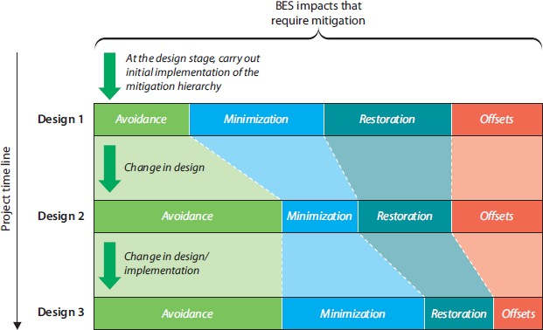

# Exercise 4: Potential impacts and dependencies

The baseline assessment has provided further information and you now have an updated map:

* Some areas of the map provides primary habitat for a migratory bird species listed as Endangered on the IUCN Red List: the Basra reed warbler. The warbler winters in the area, migrating elsewhere in the summer.
* Sea turtles use parts of the undeveloped beaches as nesting sites. These sea turtles are listed as Critically Endangered on the IUCN Red List of Threatened Species.
* There is a whale migratory route offshore.
* As well as the undisturbed forest, some has been degraded by deforestation
* Some of the mangroves remain undisturbed, but others are experiencing pollutant/sediment load on the coast from nearby human activities, which are severely degrading the mangroves.

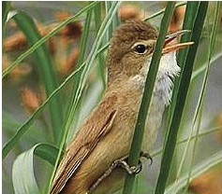 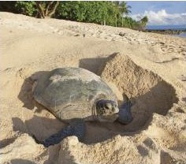 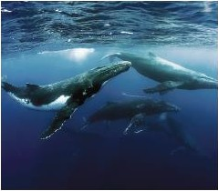

Basra reed warbler

Turtle nesting

Whale migration route

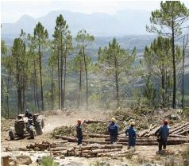 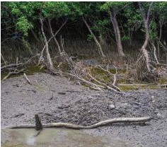

Degraded forest Degraded mangrove

**Aim:** *Understand the potential impacts as a consequence of going ahead with the project.*

1. Identify potential project dependencies and impacts for one potential solution. In addition to the platform and plant themselves, also consider:
   * Pipeline from the platform to the plant
   * Access roads

|  |  |  |
| --- | --- | --- |
| **Biodiversity component or**  **ecosystem service** | **Description of impacts** | **Description of dependencies** |
| *e.g. local subsistence fishery (provisioning services)* | *e.g.* ***Impacts*** *– Restricted access to fisheries and/or wild foods for local*  *people* | *e.g.* ***Dependencies*** *– Access to food for workforce* |
|  |  |  |
|  |  |  |
|  |  |  |
|  |  |  |
|  |  |  |
|  |  |  |

## Management and mitigation of impacts and dependencies on biodiversity and ecosystem services

**Contents**

•

•

•

•

•

What are the options for management and mitigation of impacts and dependencies?

How should companies apply the Mitigation Hierarchy?

How do these options come together in Biodiversity Action Plans / Environment Management Plans?

How are BAPs implemented?

What are the implications for regulators?

**Key messages**

* Mitigation actions should be based on the impact and dependency assessment
* Mitigation options should follow the Mitigation Hierarchy
* Mitigation should be implemented through an integrated plan such as a Biodiversity Action Plan or an Environmental and Social Management Plan
* There are trade-offs in mitigation options

# Refresher: Mitigation Hierarchy

Avoidance

* …to prevent adverse impacts on biodiversity.
* Includes activities such as **site selection**, **project design**, and **scheduling**.

Minimisation

* …to reduce the duration, intensity, significance and/or extent of impacts.
* Includes activities such as **physical controls**, **operational controls**, and **abatement controls**.

Restoration

* …to repair, remedy, remediate habitats, biodiversity values, and/or ecosystem services.
* Includes restoration activities that each have their own advantages and considerations.

Offset

* actions applied to areas not impacted by the project, that compensate for significant, adverse project impacts.
* Different types include **restoration** and **protection** offsets.
* Offsets require careful planning and consideration.

**Definition: Biodiversity Action Planning**

***Figure 29.*** *Decision tree to assess the need for a Biodiversity Action Plan (Source: IPIECA/IOGP 2005).*

**Biodiversity Action Plan:** “A plan to effectively mitigate all potential operational impacts on biodiversity and ecosystem services and identify opportunities to enhance these at local level.

More specifically …‘a set of future actions that will lead to the conservation or enhancement of biodiversity’” (IPIECA/IOGP, 2005)

Deciding on the need for a BAP



No

Are there significant observed or predicted biodiversity impacts?

Are there legal, regulatory, planning, permitting or third party requirements for a BAP?



No

Are there business benefits and a business case for a BAP?

Yes

Yes

Yes

Enter BAP process

No

Exit BAP process

# Exercise 5: Managing and mitigating impacts and dependencies

**Aim:** *Develop approaches to manage and mitigate biodiversity and ecosystem services impacts and dependencies.*

1. Use the space below to outline what example measures from the Mitigation Hierarchy could be applied to one preferred solution.
2. Include at least one idea for each step of the Mitigation Hierarchy.

**Avoid:** *e.g. alternative pipeline route to avoid running through corals*

**Minimise:** *e.g. use micro-routing to direct a pipeline along the coast, minimizing impacts on fish populations*

**Restore:** *e.g. restore degraded mangroves*

**Offset:** *e.g. establish a new fishery further along the coast*

## Monitoring and verification of company performance

**Contents**

•

•

•

•

•

What do we mean by monitoring and verification? Why is robust monitoring important?

How do companies monitor?

How can regulators and other stakeholders engage and verify? Case study from Uganda

**Key messages**

* Impact assessment does not stop at permitting
* Monitoring should support adaptive management by the company – so that results are fed back into mitigation actions
* Monitoring should be verified – which helps build trust

# Definitions: Monitoring and verification

**Indicator:** “Information or data which provides evidence of a company’s performance in addressing BES issues which are material for reporting” (IPIECA, 2015).

**Monitoring:** “The continuous or frequent standardized measurement and observation of BES, often used for warning and control” (OECD, 2007).

**Reporting:** “Disclosing relevant BES information and data to internal and external stakeholders ….such as management, Employees, governments, regulators, shareholders, the general public, local communities or specific interest groups” (IPIECA, 2015).

**Verification:** “The process of establishing the truth, accuracy, or validity of BES information & data” (Oxford Dictionary, n.d.).

**Exercise 6: Monitoring and verification**

**Aim:** *Develop indicators to monitor the status of biodiversity and ecosystem services at the project site.*

1. Which biodiversity components or ecosystem services should be monitored and why (select 3)?
   * Refer to your thoughts on baseline assessments.
2. Think which indicators might be useful. Consider: Specific, Measurable, Achievable, Relevant, and Timely (SMART) criteria.

|  |  |  |
| --- | --- | --- |
| **Biodiversity and ecosystem service indicator** | **Why?** | **What monitoring is required?** |
| *e.g. fish caught by local people for subsistence* | *e.g. increased price of local fish due to higher demand and lower supply* | *e.g. take action to reduce overfishing resulting from*  *increased demand from the project* |
|  |  |  |
|  |  |  |
|  |  |  |

# Capacity Needs and Action Planning

Throughout the course we will address the capacity needs you identify within your own countries, applicable to the national context. This space is left for you to make any notes which will help inform these sessions.

# Notes

Use this space to capture any personal notes from the course content

# Annex A: References and guiding documents Module 1

1. IFC, IPIECA, and UNDP (2017) *Mapping the Oil and Gas Industry to the Sustainable Development Goals.* Accessed from [http://www.ipieca.org/resources/awareness-](http://www.ipieca.org/resources/awareness-briefing/mapping-the-oil-and-gas-industry-to-the-sustainable-development-goals-an-atlas/) [briefing/mapping-the-oil-and-gas-industry-to-the-sustainable-development-goals-an-](http://www.ipieca.org/resources/awareness-briefing/mapping-the-oil-and-gas-industry-to-the-sustainable-development-goals-an-atlas/) [atlas/](http://www.ipieca.org/resources/awareness-briefing/mapping-the-oil-and-gas-industry-to-the-sustainable-development-goals-an-atlas/)
2. The Cross-Sector Biodiversity Initiative (2015) *A cross-sector guide for implementing the Mitigation Hierarchy.* Accessed from [http://www.csbi.org.uk/wp-](http://www.csbi.org.uk/wp-content/uploads/2017/10/CSBI-Mitigation-Hierarchy-Guide.pdf) [content/uploads/2017/10/CSBI-Mitigation-Hierarchy-Guide.pdf](http://www.csbi.org.uk/wp-content/uploads/2017/10/CSBI-Mitigation-Hierarchy-Guide.pdf)
3. Darko E (2014) *Short guide summarising the oil and gas industry lifecycle for a non- technical audience.* Overseas Development Institute, London. Accessed from [https://assets.publishing.service.gov.uk/media/57a089efed915d3cfd0004d4/Short](https://assets.publishing.service.gov.uk/media/57a089efed915d3cfd0004d4/Short_guide_summarising_the_oil_and_gas_industry_lifecycle-43.pdf)

[_guide_summarising_the_oil_and_gas_industry_lifecycle-43.pdf](https://assets.publishing.service.gov.uk/media/57a089efed915d3cfd0004d4/Short_guide_summarising_the_oil_and_gas_industry_lifecycle-43.pdf)

1. Convention on Biological Diversity (1992*) Convention on Biological Diversity.* Secretariat of the Convention on Biological Diversity, Montreal, Canada. Accessed from https://[www.cbd.int/doc/legal/cbd-en.pdf](http://www.cbd.int/doc/legal/cbd-en.pdf)
2. Mayr, E. (1942) *Systematics and the Origin of Species, from the Viewpoint of a Zoologist.* Harvard University Press, Harvard, USA. Accessed from <http://biodiversitya-z.org/content/species>
3. Millennium Ecosystem Assessment (2005) *Ecosystems and human well-being: a framework for assessment.* Island Press, Washington, D.C., USA. Accessed from <http://www.millenniumassessment.org/documents/document.767.aspx.pdf>
4. Allaby, M. (ed) (2010) *A Dictionary of Ecology.* Oxford University Press, Oxford, UK. Accessed from <http://biodiversitya-z.org/content/range>
5. Convention on Biological Diversity (1992) *Convention on Biological Diversity.* Secretariat of the Convention on Biological Diversity, Montreal, Canada. Accessed from <http://biodiversitya-z.org/content/habitat>
6. Convention on Biological Diversity (1992) *Convention on Biological Diversity.* Secretariat of the Convention on Biological Diversity, Montreal, Canada. Accessed from <http://biodiversitya-z.org/content/ecosystem>
7. Secretariat of the Convention on Biological Diversity (2000*) Decision V/6 Ecosystem approach.* Document UNEP/CBD/COP/5/6. Secretariat of the Convention on Biological Diversity, Nairobi, Kenya. Accessed from [http://www.biodiversitya-](http://www.biodiversitya-z.org/content/ecosystem-approach) [z.org/content/ecosystem-approach](http://www.biodiversitya-z.org/content/ecosystem-approach)
8. Dudley N (ed) (2008) *Guidelines for applying protected area management categories.* IUCN, Gland, Switzerland. Accessed from: [http://www.biodiversitya-](http://www.biodiversitya-z.org/content/protected-area) [z.org/content/protected-area](http://www.biodiversitya-z.org/content/protected-area)
9. IUCN (2016) *A global standard for the identification of Key Biodiversity Areas.* IUCN, Gland, Switzerland. Accessed from: <https://portals.iucn.org/library/node/46259>
10. The KBA Partnership (2018) *Guidelines on Business and KBAs: Managing Risk to Biodiversity.* IUCN, Gland, Switzerland. Access from: <https://portals.iucn.org/library/sites/library/files/documents/2018-005-En.pdf>
11. Natural Capital Coalition (2016) *The Natural Capital Protocol.* Accessed from <https://naturalcapitalcoalition.org/natural-capital-protocol/>
12. Millennium Ecosystem Assessment (2005) *Ecosystems and human well-being: a framework for assessment.* Island Press, Washington, D.C., USA. Accessed from <http://www.millenniumassessment.org/documents/document.767.aspx.pdf>
13. IPIECA (2005) *A guide to developing biodiversity action plans for the oil and gas sector.* Access from: [http://www.ipieca.org/resources/good-practice/a-guide-to-](http://www.ipieca.org/resources/good-practice/a-guide-to-developing-biodiversity-action-plans-for-the-oil-and-gas-sector/) [developing-biodiversity-action-plans-for-the-oil-and-gas-sector/](http://www.ipieca.org/resources/good-practice/a-guide-to-developing-biodiversity-action-plans-for-the-oil-and-gas-sector/)
14. IPIECA (2011) *Ecosystem services guidance.* Accessed from [http://www.ipieca.org/resources/good-practice/ecosystem-services-guidance-](http://www.ipieca.org/resources/good-practice/ecosystem-services-guidance-biodiversity-and-ecosystem-services-guide/) [biodiversity-and-ecosystem-services-guide/](http://www.ipieca.org/resources/good-practice/ecosystem-services-guidance-biodiversity-and-ecosystem-services-guide/)
15. IPIECA (2016) *Biodiversity and ecosystem service fundamentals.* Accessed from [http://www.ipieca.org/resources/good-practice/biodiversity-and-ecosystem-](http://www.ipieca.org/resources/good-practice/biodiversity-and-ecosystem-services-fundamentals/) [services-fundamentals/](http://www.ipieca.org/resources/good-practice/biodiversity-and-ecosystem-services-fundamentals/)
16. CSBI (2015) *Good practices for the collection of biodiversity baseline data.* Prepared by Gullison, R. E. et al. for the Multilateral Financing Institutions Biodiversity Working Group and the Cross-Sector Biodiversity Initiative. Accessed from [http://www.csbi.org.uk/wp-](http://www.csbi.org.uk/wp-content/uploads/2017/11/Biodiversity_Baseline_JULY_4a-2.pdf) [content/uploads/2017/11/Biodiversity_Baseline_JULY_4a-2.pdf](http://www.csbi.org.uk/wp-content/uploads/2017/11/Biodiversity_Baseline_JULY_4a-2.pdf)
17. IPIECA (2015) *Oil and gas industry guidance on voluntary sustainability reporting.* Accessed from [http://www.ipieca.org/resources/good-practice/oil-and-gas-](http://www.ipieca.org/resources/good-practice/oil-and-gas-industry-guidance-on-voluntary-sustainability-reporting-3rd-edition/) [industry-guidance-on-voluntary-sustainability-reporting-3rd-edition/](http://www.ipieca.org/resources/good-practice/oil-and-gas-industry-guidance-on-voluntary-sustainability-reporting-3rd-edition/)

# Module 2

1. Ministry of Infrastructure and the Environment (2011) *Summary National Policy Strategy for Infrastructure and Spatial Planning.* Accessed from [https://www.government.nl/binaries/government/documents/publications/2013/0](https://www.government.nl/binaries/government/documents/publications/2013/07/24/summary-national-policy-strategy-for-infrastructure-and-spatial-planning/summary-national-policy-strategy-for-infrastructure-and-spatial-planning.pdf) [7/24/summary-national-policy-strategy-for-infrastructure-and-spatial-](https://www.government.nl/binaries/government/documents/publications/2013/07/24/summary-national-policy-strategy-for-infrastructure-and-spatial-planning/summary-national-policy-strategy-for-infrastructure-and-spatial-planning.pdf) [planning/summary-national-policy-strategy-for-infrastructure-and-spatial-](https://www.government.nl/binaries/government/documents/publications/2013/07/24/summary-national-policy-strategy-for-infrastructure-and-spatial-planning/summary-national-policy-strategy-for-infrastructure-and-spatial-planning.pdf) [planning.pdf](https://www.government.nl/binaries/government/documents/publications/2013/07/24/summary-national-policy-strategy-for-infrastructure-and-spatial-planning/summary-national-policy-strategy-for-infrastructure-and-spatial-planning.pdf)
2. Blue Solutions Initiative, MARISMA Project. *Marine Spatial Planning (MSP) in a nutshell”* Available at: <https://vimeo.com/219515087>
3. United Nations Economic Commission for Europe (2017) *Protocol on Strategic Environmental Assessment: Facts and Benefits.* Accessed from [http://www.green-](http://www.green-economies-eap.org/resources/1609217_UNECE_HR.pdf) [economies-eap.org/resources/1609217_UNECE_HR.pdf](http://www.green-economies-eap.org/resources/1609217_UNECE_HR.pdf)
4. Video: “The UNECE Protocol on Strategic Environmental Assessment.” Available at: <https://youtu.be/KTHKqx-C_C8>
5. Liu, X et al. (2015) *Assessing oil spill risk in the Chinese Bohai Sea: A case study for both ship and platform related oil spills.* Ocean & Coastal Management 108: 140-146. DOI: [10.1016/j.ocecoaman.2014.08.016](https://doi.org/10.1016/j.ocecoaman.2014.08.016)
6. Santos et al. (2013) *Marine spatial planning and oil spill risk analysis: Finding common grounds.* Marine Pollution Bulletin 74(1): 73-81. DOI: [10.1016/j.marpolbul.2013.07.029](https://doi.org/10.1016/j.marpolbul.2013.07.029)
7. Gil-Agudelo et al. (2015) *Environmental Sensitivity Index for oil spills in marine and coastal areas in Colombia.* CT&F 6(1): 17-28. URL: [www.scielo.org.co/pdf/ctyf/v6n1/v6n1a02.pdf](http://www.scielo.org.co/pdf/ctyf/v6n1/v6n1a02.pdf)
8. ECOSCAPE (2016) *District of Squamish: Sensitive Ecosystem Inventory (SEI) and Environmentally Sensitive Areas Mapping.* URL: [https://squamish.ca/assets/2016-](https://squamish.ca/assets/2016-January-SEI-Final-Report.PDF) [January-SEI-Final-Report.PDF](https://squamish.ca/assets/2016-January-SEI-Final-Report.PDF)
9. IPIECA, IMO, IOGP (2016) *Sensitivity mapping for oil spill response: Good practice guidelines for incident management and emergency response personnel.* Accessed from [http://www.ipieca.org/resources/good-practice/sensitivity-mapping-for-oil-](http://www.ipieca.org/resources/good-practice/sensitivity-mapping-for-oil-spill-response/) [spill-response/](http://www.ipieca.org/resources/good-practice/sensitivity-mapping-for-oil-spill-response/)
10. NOAA (2002) *Environmental Sensitivity Index Guidelines Version 3.0.* Accessed from <https://response.restoration.noaa.gov/sites/default/files/ESI_Guidelines.pdf>
11. Natural Capital Project. Integrated Valuation of Ecosystem Services and Trade-offs (InVEST). Available at: <https://naturalcapitalproject.stanford.edu/invest/>.
12. Eden, C. and Ackermann, F. (1998) *Making Strategy: The Journey of Strategic Management*, London: Sage Publications.
13. Schneider, R. R. et al. (2011) *Achieving Conservation when Opportunity Costs Are High: Optimizing Reserve Design in Alberta's Oil Sands Region.* PLoS One 6(8): e23254. DOI: [10.1371/journal.pone.0023254](https://doi.org/10.1371/journal.pone.0023254)
14. Martin, C. S. et al. (2015) *A global map to aid the identification and screening of critical habitat for marine industries.* Marine Policy 53: 45-53. DOI: [10.1016/j.marpol.2014.11.007](https://doi.org/10.1016/j.marpol.2014.11.007)

# Module 3

1. United Nations Environment Programme (2002) *Environmental Impact Assessment Training Resource Manual*. UNEP, Geneva, Switzerland. Available at <https://unep.ch/etb/publications/EIAMan_2edition_toc.htm>
2. International Finance Corporation (2012) *Performance Standard 6: Biodiversity Conservation and Sustainable Management of Living Natural Resources.* Accessed from [https://www.ifc.org/wps/wcm/connect/topics_ext_content/ifc_external_corporate_](https://www.ifc.org/wps/wcm/connect/topics_ext_content/ifc_external_corporate_site/sustainability-at-ifc/policies-standards/performance-standards/ps6) [site/sustainability-at-ifc/policies-standards/performance-standards/ps6](https://www.ifc.org/wps/wcm/connect/topics_ext_content/ifc_external_corporate_site/sustainability-at-ifc/policies-standards/performance-standards/ps6)
3. Kotiaho, J. S. et al. (2016). *Framework for assessing and reversing ecosystem degradation – Report of the Finnish restoration prioritization working group on the options and costs of meeting the Aichi biodiversity target of restoring at least 15 percent of degraded ecosystems in Finland*. Accessed from: <http://julkaisut.valtioneuvosto.fi/handle/10024/74862>
4. Cross-Sector Biodiversity Initiative (CSBI). (2015) *Good Practices for the Collection of Biodiversity Baseline Data*. Available at: [http://www.csbi.org.uk/wp-](http://www.csbi.org.uk/wp-content/uploads/2017/11/Biodiversity_Baseline_JULY_4a-2.pdf) [content/uploads/2017/11/Biodiversity_Baseline_JULY_4a-2.pdf](http://www.csbi.org.uk/wp-content/uploads/2017/11/Biodiversity_Baseline_JULY_4a-2.pdf).
5. The Energy and Biodiversity Initiative (EBI) (2006) *Integrating biodiversity in ESIA processes*. Available at: <http://www.theebi.org/pdfs/esia.pdf>.
6. IBAT for Business. (2018). Available at: <https://www.ibatforbusiness.org/>
7. IPIECA-OGP. (2011) Ecosystem services checklists. Available at: [http://www.ipieca.org/resources/good-practice/ecosystem-services-guidance-](http://www.ipieca.org/resources/good-practice/ecosystem-services-guidance-biodiversity-and-ecosystem-services-checklists/) [biodiversity-and-ecosystem-services-checklists/](http://www.ipieca.org/resources/good-practice/ecosystem-services-guidance-biodiversity-and-ecosystem-services-checklists/).
8. IPIECA-IOGP. (2016) *Biodiversity and ecosystem services fundamentals: Guidance document for the oil and gas industry.* Available at: [http://www.ipieca.org/resources/good-practice/biodiversity-and-ecosystem-](http://www.ipieca.org/resources/good-practice/biodiversity-and-ecosystem-services-fundamentals/) [services-fundamentals/](http://www.ipieca.org/resources/good-practice/biodiversity-and-ecosystem-services-fundamentals/).
9. IFC. (2012). *Performance Standard 6: Biodiversity Conservation and Sustainable Management of Living Natural Resources.* Available at: [https://www.ifc.org/wps/wcm/connect/bff0a28049a790d6b835faa8c6a8312a/PS6](https://www.ifc.org/wps/wcm/connect/bff0a28049a790d6b835faa8c6a8312a/PS6_English_2012.pdf?MOD=AJPERES)

[_English_2012.pdf?MOD=AJPERES](https://www.ifc.org/wps/wcm/connect/bff0a28049a790d6b835faa8c6a8312a/PS6_English_2012.pdf?MOD=AJPERES).

1. IUCN 2018. The IUCN Red List of Threatened Species. Version 2018-1. Available at: [http://www.iucnredlist.org](http://www.iucnredlist.org/). Downloaded on 05 July 2018.
2. UNEP-WCMC and IUCN (2018), Protected Planet: The World Database on Protected Areas (WDPA) [On-line], September 2018, Cambridge, UK: UNEP-WCMC and IUCN. Available at: [www.protectedplanet.net](http://www.protectedplanet.net/).
3. Laurance, W. F. et al. (2015) Reducing the global environmental impacts of rapid infrastructure expansion. *Current Biology* 25(7): PR259-R262. Doi: [10.1016/j.cub.2015.02.050](http://doi.org/10.1016/j.cub.2015.02.050).
4. OECD (2007) *Definition - Monitoring (environmental).* Accessed from: <https://stats.oecd.org/glossary/detail.asp?ID=1684>
5. Oxford Dictionaries (n.d.) *Definition: Verification.* Accessed from: <https://en.oxforddictionaries.com/definition/verification>
6. The Energy and Biodiversity Initiative (2003) Biodiversity indicators for monitoring impacts and conservation actions. Accessed from: <http://www.theebi.org/pdfs/indicators.pdf>

environment • FOR DEVELOPMENT UN@ ll



UN@

environment WCMC

**IPIECA**