Participant’s Guidebook

**National Training Course on Chemicals and Waste Management in Oil and Gas Exploration and Production**

(insert dates here)

(insert names of country and city here)

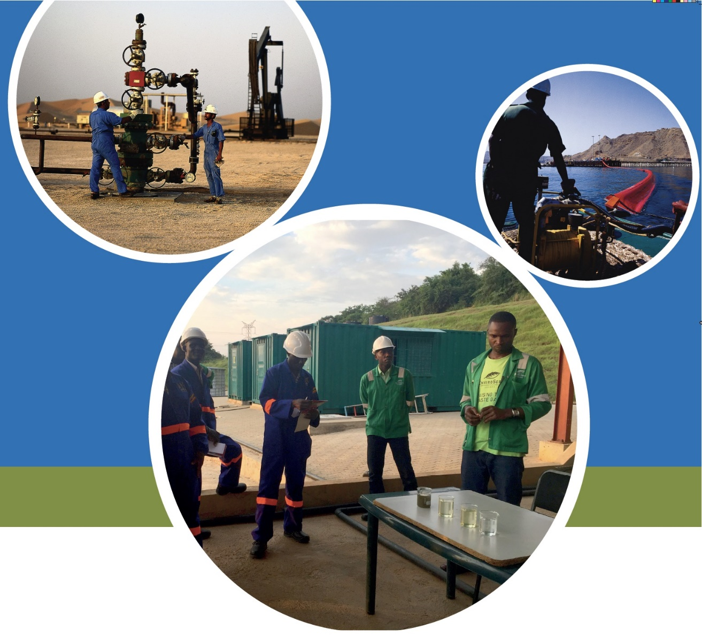

PARTICIPANT’S NAME

This publication may be reproduced for educational or non - profit purposes without special permission, provided acknowledgement to the source is made. Reuse of any figures, data or pictures is subject to permission from the original rights holders. No use of this publication may be made for resale or any other commercial purpose without permission in writing from UN Environment Programme (UNEP). Applications for permission, with a statement of purpose and extent of reproduction, should be sent to the Executive Director, UNEP, United Nations Office at Nairobi P. O. Box 67578. Nairobi, Kenya 00200.

The contents of this report do not necessarily reflect the views or policies of UNEP, contributory organizations or editors. The designations employed and the presentations of material in this report do not imply the expression of any opinion whatsoever on the part of UNEP or contributory organizations, editors or publishers concerning the legal status of any country, territory, city area or its authorities, or concerning the delimitation of its frontiers or boundaries or the designation of its name, frontiers or boundaries. The mention of a commercial entity or product in this publication does not imply endorsement by UNEP.

This Participants’ Guide has been prepared for capacity building only and does not constitute professional advice. The information contained within the workshop material should not be relied upon as a substitute for appropriate technical expertise or professional advice. Nor representation or warranty (express or implied) is given as to the accuracy of completeness of the information contained within it.

To the extent permitted by law, UNEP, their members, employees and agents do not accept or assume any liability, responsibility or duty of care for any consequences of you or anyone else acting, or refraining to act, in reliance on the information contained in this capacity building programme or for any decision based on it.

Participant Guide Copyright 2019 United Nations Environment Programme

Table of Contents

Background 4

UN Environment Programme and Oil for Development Partnership 5

The Training Course 6

Key Learning Objectives of this Course 7

Expected Outputs 7

Target Audience 7

Course Duration 8

Meet the Training Team 8

Training Programme: 9

Day 1 13

Participant Introductions - Poster session 13

Participants-led Daily Recaps 13

Module 1. An Overview of Oil and Gas Exploration and Production 14

Day 2 21

Module 2. Chemicals within the oil and gas sector 21

Module 3. Generation of waste related to oil and gas exploration and production 23

Group Exercise: Conducting a Site Inspection 26

Briefing on the Field Trip in Day 3 27

Day 3 29

Field visit 29

Day 4 29

Module 4. Management of chemicals and waste related to oil and gas exploration and production 30

Module 4.1. Current national policies, laws, regulations related to chemicals and waste management 30

Module 4.2. Management of chemicals and wastes in the oil and gas sector – International / industry good practices 31

Module 4.3. Chemicals and waste regulation: Experience from Norway and the international context 34

Final Group Exercise: Action Planning 36

References 37

## Background

Oil and gas exploration and production activities handle a range of chemicals, from explosives to radioactive substances, as part of routine operations. The oil and gas industry also produces different types of waste materials in all phases of its operations. Thus, chemicals and waste management are an integral part of oil and gas exploration and production activities. If chemicals and waste are inadequately managed, they can have lasting environmental impacts, which can affect livelihoods and public health. Proper chemicals and waste management help avoid these adverse impacts on human health and the environment.

In this regard, UN Environment Programme (UNEP) together with Norway’s Oil for Development (OfD) Programme have developed this training in order to strengthen national institutional capacities to better manage chemicals and waste within the upstream oil and gas sector. This training is part of a series of trainings delivered by UNEP in OfD-supported countries.

**What is the aim of this course?**

This training course aims to enhance understanding of the key operational and environmental aspects of, and options for, chemicals and waste management in oil and gas exploration and production.

This training is a specialized course, which builds on the Foundation Course on Oil and Gas Exploration and Production and Promoting Sound Environmental Management.

## UN Environment Programme and Oil for Development Partnership

As the world transitions towards low carbon economies to mitigate climate change, it is recognized that oil and gas will continue to play a role in the global energy mix. It will still be important to provide support to developing countries with oil and gas reserves, and enable them to better manage the use of their hydrocarbon resources in a responsible and sustainable manner and to prevent and reduce adverse environmental impacts.

Fragile and developing countries can now benefit from over 30 years of international best practice on environmental management in the oil and gas sectors to support sustainable development. Enabling countries to access this know-how is the key goal of the partnership between UNEP and the Government of Norway’s Oil for Development Programme.

In 2005, the Government of Norway established its Oil for Development (OfD) Programme, with the aim of supporting fragile and developing countries to promote “socially, economically and environmentally responsible management of petroleum resources which safeguards the needs of future generations”. The OfD Programme supports the holistic approach to petroleum management, with a strong Environment Pillar. OfD currently cooperates with 14 countries: Angola, Colombia, Cuba, Ghana, Iraq, Lebanon, Kenya, Mozambique, Myanmar, Somalia, South Sudan, Sudan, Tanzania/Zanzibar and Uganda.

Under the Environment Pillar of the OfD Programme, the Government of Norway and UNEP have established a 5-year collaboration (2016-2021) to enhance national capacities for improved environmental management in the oil and gas sectors in the 14 OfD-supported countries; and reduce the environmental risks associated with the development of hydrocarbon resources.

UNEP has experience working with the oil industry in fragile and vulnerable countries and delivering capacity building support. It can draw from its in-house expertise and global network of partners, which will complement the specialized assistance provided by Norway. Main services provided by UN Environment include:

1. National- and regional-level trainings on a number of topics related to environmental management in the oil and gas sector;
2. Direct technical assistance to countries, working with local and national government counterparts;
3. In-country institutional capacity needs assessments for strengthening national environmental management in oil and gas exploration and production (upstream sector); and
4. Building a global community-of-practice to further increase awareness and networking on environmental management best practices in the oil and gas sector.

For further information, visit: https://www.unenvironment.org/explore-topics/disasters-conflicts/what-we-do/risk-reduction/extractive-resources-and-fragile-0





Join our Global Network on Environment and Oil and Gas on [LinkedIn](https://www.linkedin.com/in/global-network-on-environment-and-oil-and-gas-a417a3163) and subscribe to our [monthly](https://pedrr.us10.list-manage.com/subscribe?u=cf4b6e9f4c74832358b014e66&id=836cd22cad) newsletter.

## The Training Course

As the oil and gas sector in Kenya is expanding both onshore and offshore, use of chemicals and the different types of wastes generated will require proper management and regulation. This training on *‘Chemicals and Waste Management in Oil and Gas Exploration and Production’* is being delivered in collaboration with the Government of XXX’s XXX under Kenya’s Oil for Development Country Programme (2019-2023, under finalization).

|  |  |
| --- | --- |
| **Summary of workshop structure** | |
| **Module** | **Sub-section** |
| **1**  **An overview of oil and gas exploration with case study** | * Where does oil and gas come from? * Short history of the oil industry * Why is this topic important? * Environmental issues of seismic, drilling & production operations * Main issues related to chemicals and waste * Lesson learned from the case study |
| **2**  **Chemicals within the Oil and Gas Sector** | * What are chemicals and why are they of concern * Different types of chemicals, their properties and their classification * Chemicals used in various phases (drilling, production, etc.) of the oil and gas sector * Materials Safety Data Sheets * Radioactive substances used in the oil industry * Transportation of chemicals * Control of Substances Hazardous to Health (COSHH) |
| **3**  **Generation of Waste Related to Oil and Gas Exploration and Production** | * What is waste and why is it of concern * Hazardous and non-hazardous wastes * Waste specific to the oil and gas industry (drilling fluids, produced water, emissions to air, etc) * Naturally Occurring Radioactive Materials in oil industry * Environmental impacts of different wastes |
| **Field Visit** | |
| **4**  **Management of Chemicals and Waste Related to Oil and Gas Exploration and Production** | * Waste Management Facilities * Waste Management Plans * On-site management and storage * Waste-to-Energy Approaches * Environmental controls and permitting * Waste treatment and disposal options * Regulations on transboundary movement of wastes * Compliance monitoring (inspections and audits) * Basics on contingency planning and personal protective equipment * International frameworks and policies on chemicals and waste management |
| **5**  **Way Forward / Action Planning** | * Identifying and prioritizing country capacity needs * Proposed actions for improving management of chemicals and waste management in oil and gas exploration and production |

### Key Learning Objectives of this Course

Participants are expected to:

1. Develop basic knowledge of the key environmental concerns associated with chemicals and waste management at each stage of (upstream) oil and gas exploration and production.
2. Identify the main components of, and options for, chemicals and waste management in oil and gas exploration and production – both at the national and international level.
3. Be familiar with fundamental health and safety requirements along with the use of personal protective equipment (PPE) when dealing with chemicals and wastes.
4. Understand basic techniques and tools for environmental monitoring of the oil and gas sector as it relates to chemicals and waste management.
5. Learn about international laws, regulations and best practices as they relate to chemicals and waste management.
6. Identify and prioritize capacities and needs for strengthening chemicals and waste management in the country,

### Expected Outputs

* Enhanced knowledge of chemicals and waste management and regulatory activities as they relate to the oil and gas sector in the country
* End-of-Course evaluation of participant’s knowledge
* Group Action Plan to address prioritized capacity needs for strengthening chemicals and waste management and regulatory activities as they relate to the oil and gas sector in the country
* Networking for enhanced national coordination on chemicals and waste management within the oil and gas sector

### Target Audience

This course is geared primarily towards officials from National and Local Government institutions which are responsible for overseeing oil and gas development and promoting sound environmental management in the sector, including regulation and compliance monitoring. Government Ministries/Departments/Agencies from other development sectors (e.g. infrastructure, water, agriculture/fisheries, tourism, land-use planning, etc.) are also encouraged to participate.

Training participants may also include:

* Nationally-registered consultants who support environmental assessments in the sector (e.g. Environmental/Social Impact Assessments, Strategic Environment Assessments, Audits, Compliance Monitoring, etc.)
* Staff from national universities/academia who teach or provide trainings related to oil and gas operations
* Civil society and other non-governmental actors.

UN Environment strives to achieve gender-balanced representation in all its trainings.

### Course Duration

This a 4-day training take place from XXX, which will include a field visit on XXX.

### 

### Meet the Training Team

|  |  |
| --- | --- |
|  | ***Mr. Michael J Cowing – Course Leader, Independent Environmental Consultant***  Michael J Cowing is an award-winning environmental scientist who possesses over thirty years of international experience within the environmental and waste management sectors. Throughout his career he has operated in more than fifty countries globally – over ten of which are in Africa. Michael led UN Environment’s ground-breaking work in Ogoniland, Nigeria; and has worked on environmental and waste management issues related to the oil and gas sector in Africa, The Middle East, South East Asia, Europe and the Eastern Caribbean. Michael has an MSc in Environmental Science (Manchester, UK), a BSc in Bio-Geography (Surrey, UK), a Diploma in Waste Management (London, UK) as well as many other certificates such as oil-spill response, contaminated land investigation and remediation and Health & Safety. |
|  | ***Ms. Marisol Estrella, Coordinator, UN Environment-Oil for Development Partnership***  Marisol Estrella is Programme Coordinator for Disaster Risk Reduction in the Post-Conflict and Disaster Management Branch of the United Nations Environment Programme (UNEP), based in Geneva, Switzerland. She has more than 10 years in the field of environment and disaster risk management, working on policy advocacy, trainings and capacity development, field projects and partnerships. She holds an M.A. with Distinction in Environment, Development and Policy from University of Sussex, UK, and B.A. with First Class Honours in Anthropology and Environmental Studies from University of McGill, Canada. |
|  | ***Ms. Chidinma Zik-Ikeorha, Project Support, UN Environment-Oil for Development Partnership***  Chidinma Zik-Ikeorha works as a Research Assistant in the Post-Conflict and Disaster Management Branch of the United Nations Environment Programme (UNEP), based in Geneva, Switzerland. She provides support on the UN Environment-OfD Partnership project. She holds a B.L in Law from Abia State University Nigeria and an LL.M in International Law from the University of Dundee, Scotland. She worked with UNITAR in the International Law programme, where she developed training materials and assisted in project coordination. She was a Legal officer for an Energy firm in Nigeria and has worked with different Human Rights NGOs in the USA. |

### Training Programme:

|  |  |
| --- | --- |
| **Time** | **Activity** |
| **Day 1, Tuesday, XXX** | |
| 8.30 | **Registration**  **Safety Briefing and Welcome**  *Marisol Estrella, UNEP* |
| 9:00 | **Opening Remarks**  *XXX, XXX*  *XXX on behalf of the Oil for Development Programme* |
| 9:30 | **Introduction of Participants and Training Team**  **Course Overview and Expectations/What participants hope to gain from the course**  **Baseline Knowledge Assessment**  *Chidinma Zik-Ikeorha, UNEP* |
| 10:30 | **Coffee/Tea Break** |
| 10:45 | **Module 1: Why are we here?**  **Case study: Why chemicals and waste management are important**  *M J Cowing UNEP*  Q&A |
| 11:30 | **Module 1: continued**  **A brief overview of oil and gas exploration and production**  *M J Cowing, UNEP*  *Q&A* |
| 12:30 | **Coffee/Tea Break** |
| 13:30 | **Learning game: A-Z of chemicals and waste management**  *Chidinma Zik-Ikeorha, UNEP* |
| 14:00 | **Module 1: Overview, continued**  **Presentation on XX’s experience on waste issues during drilling and production: Challenges and Lessons Learned**  ***NEMA*** |
| 15:30 | **Coffee/Tea Break** |
| 16:00 | **Module 1: Overview, Continued**  **What is environmental compliance monitoring? Sharing experiences from Norway**  *XXx, Norwegian Environment Agency*  **Q&A** |
| 17:00 | **Team reflections**  *Chidinma Zik-Ikeorha, UNEP* |
| 17:30 | **End of day / Taking the Pulse**  *Chidinma Zik-Ikeorha, UNEP* |
| **Day 2, Wednesday, 20 March 2019** | |
| 8:30 | **Participants-led Recap of Day 1 – Pop Quiz!**  *Chidinma Zik-Ikeorha, UNEP* |
| 9:00 | **Module 2: Chemicals within the Oil and Gas Sector**  **Presentation using slides and videos**  *M. J Cowing, UNEP*  **Q&A** |
| 10:30 | **Coffee/Tea Break** |
| 10:45 | **Module 3: Generation of Waste Related to Oil and Gas Exploration and Production**  **Presentation and Discussion**  *M. J Cowing, UNEP*  **Q&A** |
| 12:30 | **Lunch** |
| 13:30 | **Module 3: Generation of Waste Related to Oil and Gas Exploration and Production (continued)**  **Group Work and Group Presentations**  *M. J Cowing, UNEP* |
| 15:30 | **Coffee/Tea Break** |
| 16:00 | **Briefing on the Field Trip**  *XXX, XXX* |
| 16:30 | **Team Reflections**  *Chidinma Zik-Ikeorha, UNEP* |
| 17:00 | **End of Day /Taking the Pulse** |
| **Day 3, Thursday, XXX** | |
| 8:30 | **Depart for Field trip – Departure from training venue** |
| 16:00 | **Return from Field trip** |
| **Day 4, Friday, XXX** | |
| 8:30 | **Recap of Days 2 and 3, Field Trip**  *Chidinma Zik-Ikeorha, UNEP* |
| 9:00 | **Group Work and Presentations from the field trip**  *M. J Cowing, UNEP* |
| 10:30 | **Coffee/tea break** |
| 10:45 | **Module 4 - Management of Chemicals & Waste Related to Oil and Gas Exploration and Production**  **Current National Policies, Laws and Regulations related to Chemicals and Waste Management**  *XXX*  **Presentation on international / industry good practices**  *M J Cowing, UNEP*    **Q&A** |
| 12:30 | **Lunch** |
| 13:30 | **Module 4 - Management of Chemicals & Waste Related to Oil and Gas Exploration and Production**  **Chemicals and Waste Regulations: Experience from Norway and the international context**  *XXX, Norwegian Environment Agency*  **Q&A** |
| 14:30 | **Mapping Challenges and Opportunities: Action Planning / Team work**  *Marisol Estrella, UNEP* |
| 15:00 | **Working Coffee/tea break** |
| 15:30 | **Presentations of Action Plans** |
| 16:30 | **Wrap Up**  **Final Knowledge Assessments**  **Training Evaluations**  **Awarding of Certificates**  **Closing Remarks**  *Representative from XXX*    *XX, Norwegian Environment Agency*  *Marisol Estrella, UN Environment* |
|  | **Participants depart** |

### Day 1

### Participant Introductions - Poster session



|  |
| --- |
| * Your name * Your organization/institution * Your expectation from this training * Something about yourself that you would like to share and be remembered (e.g. a hobby, favorite music, etc) |

### Participants-led Daily Recaps

Participants will be divided into teams. Each team will be responsible for leading the Daily Recaps the following day, as the first daily activity. To prepare for this, each team is encouraged to summarize the discussions. You can be as creative as you can! e.g. prepare a quiz, role play, etc.

**Each team is asked to present on the following: You will have maximum 15 minutes.**

1. What are your top 3 key messages/lessons from the previous day?

2. How do these lessons/messages relate to your own institutional or country context?

3. What did you like about the sessions? What did you not like?

### Module 1. An Overview of Oil and Gas Exploration and Production

**Module 1.1. Why are we here? The case of the Niger Delta**

**Contents:**

* Background to Ogoniland and UN Environment’s assessment of oil contamination
* Main issues related to chemicals and waste
* Impacts on water, land, air and public health
* Lesson learned from the Ogoniland experience

**Learning objectives**

* Describe the environmental (and social) consequences of improper management of chemicals and waste in the oil and gas sector;
* Identify lessons learned from the case study and how it may be applied in your own country context.

**Key messages**

* The case of the Niger Delta illustrates the importance of ensuring proper institutions, legal frameworks and standards of waste management are in place
* Based on UN Environment’s environmental assessment in Ogoniland, oil contamination has had significant environmental, social and public health impacts.
* Government agencies need to have qualified technical experts, equipment and budget; and should not depend on oil companies to visit spill sites.
* Lack of clarity of institutional roles and poor coordination result in duplication, inefficiencies and overlap of roles.
* There should be standards set for hazardous substances such as benzene, and existing laws need to specify who is responsible.
* Different interpretation of the law by different government agencies can lead to inefficiency in management of chemicals and waste in the oil and gas sector. Hierarchy of laws and clarification on roles and responsibilities are essential.

**Add any other take-away messages and key lessons for you:**



**Module 1.2. An Overview of Oil and Gas Exploration and Production**

**Contents**

* Where does oil and gas come from?
* Short history of the oil industry
* Why is this topic important?
* Oil and gas sector and the Sustainable Development Goals (SDGs)

**Learning objectives**

* Describe the oil and gas industry value chain and key stages of upstream oil and gas exploration and production
* Understand the oil and gas industry in the global context
* Appreciate the relationship of the oil and gas industry with achieving the country’s Sustainable Development Goals

**Key messages**

* Oil and gas provide an important energy source globally, but is more than just fuel; more than 6,000 products are derived/refined from natural gas and crude oil. These include plastics, medicines, home furniture, toiletries, tools, etc.
* The oil and gas industry value chain consists of the following: Upstream oil and gas (exploration, field development, production), midstream (transportation, processing, storage etc) and downstream (manufacturing, refining, etc)
* It is fundamental to align oil & gas operations within the Sustainable Development Goals (SDGs) of the country and national commitments to reduce greenhouse gas emissions under the Paris Agreement on Climate Change.
* Key Sustainable Development Goals that relate to the oil and gas industry include: gender (SDG 5), water (SDG 6), inclusive and sustainable growth (SDG 8), infrastructure (SDG 9), climate change (SDG 13), oceans (SDG 14), biodiversity and terrestrial ecosystems (SDG 15)

**Add any other take-away messages and key lessons for you:**



**Experiences and lessons from XX on chemicals and waste management in the oil and gas sector will be presented by NEMA. Note down your key take-away messages from this presentation.**



**A-Z Learning Game - Instructions**

**Participants will be divided into 2 groups. Each participant in the group will pick a card/Post-it and will look for a participant from the opposite group with a corresponding post-it/card, so both participants can form a pair.**

**For example:**

**Personal Protective Equipment**

**PPE**

Participant (Group B)

Participant (Group A)

**Module 1.3. What is environmental compliance monitoring? Experience from Norway**

**Contents:**

* Objectives of environmental compliance monitoring
* Types of inspections
* How inspections are carried out
* Operators responsibilities
* Preparation and undertaking environmental audits
* Conducting on-site verifications
* Polluter Pays principle

**Learning objectives**

* Gain basic understanding of the key elements of environmental compliance monitoring and why compliance monitoring is important
* Describe basic tools for compliance monitoring which relate to chemicals and waste management in the oil and gas sector;
* Understand the general differences between site inspections vs. audits
* Learn about experiences from Norway on environmental compliance monitoring and compare with Kenya’s experiences

**Key messages**

* Environmental compliance monitoring is important because it enables Government regulators to:
  + Check whether the operator has complied with laws, regulations, permits and their own environmental management systems
  + Collect documentation in the case of non-compliance
  + Verify the quality of data reported by operators
  + Impose necessary enforcement actions
* Environmental compliance may be undertaken in several ways, including: carrying out audits and site inspections, evaluating reports and giving feedback, and having regular communications with the operator.
* Site inspections may focus on specific aspects of the permit or procedures or a reported incident and may take place un-announced; whereas audits would generally be more comprehensive in scope, including reviewing the operator’s performance against Acts/regulations/ permits, operators’ reports and their own environmental management systems, and requires advanced planning with notice given to the operator.
* Compliance monitoring of the operator’s performance is best undertaken in the field.

**Add any other take-away messages and key lessons for you:**



**Group work exercise: What is the difference between a site inspection vs. an audit?**

Working in your teams, and based on your understanding and own experiences, discuss the difference between a site inspection vs an audit. On a flipchart, make two columns to compare these differences. You will have 15 minutes for discussion, and we will report back in plenary and consolidate our knowledge.

Keep in mind these questions:

1. What are the objectives and scope?
2. What steps are needed to prepare for, and conduct, a field inspection and an audit?
3. What resources are needed? What types of expertise is needed?

For example:

|  |  |
| --- | --- |
| Key elements of a site inspection | Key elements of an audit |
|  |  |

**End of Day 1 – Team Reflections**

Take a 5-10 minutes to discuss in teams the following:

1. What are Your key lessons learned today?

2. What are the main institutional capacity challenges/gaps with regards to chemicals and waste management that apply to our country context?

3. Are there any current efforts, opportunities or entry points to address these challenges within our own country context?

Based on your discussions, **record the identified capacity challenges on post-its. 1 challenge = 1 post-it.** For each identified capacity challenge, **record on a separate post-it, the identified opportunity or entry point/s for addressing that particular challenge**. Paste post-its on your Team reflection flipchart in the room. You will continue to build this Team reflection flipchart at the end of each day. It should look like this.

Team reflection flipchart sample:

|  |  |
| --- | --- |
| **Identified Capacity Challenge** | **Current efforts, opportunity or entry point for addressing the challenge** |
| Challenge 1  Challenge 2 | Opportunity / Entry point to address challenge 2  Opportunity/ Entry point to address challenge 1 |

### Day 2

**Participants’ led Recap of Day 1**

Record the key take-away messages here presented by the team. Please add your own!



### Module 2. Chemicals within the oil and gas sector

**Contents:**

* Types of chemicals in the oil and gas sector
* Content and properties of chemicals
* Main activities in the oil and gas value chain when chemicals are used
* Potential environmental impacts of chemicals used during drilling and production operations
* Materials Safety Data Sheet: content, uses and responsibility
* Transportation of hazardous substances
* Control of substances hazardous to Health (COSHH) and its management

**Learning objectives**

* Understand why and where chemicals are used within the upstream oil and gas sector
* Identify the general types of chemicals and their intrinsic properties
* Distinguish between water-based and oil-based or synthetic drilling fluids and understand their environmental considerations
* Appreciate management aspects with regards to the transportation of chemicals, including the roles/responsibilities of the operator.

**Key messages**

* Chemicals are used throughout various stages of the upstream oil and gas value chain, starting from drilling the well, to well completion, to production to storage and transportation.
* Chemicals may be categorized as organic chemicals (carbon-based) or as inorganic chemicals (non-carbon based). Chemicals may have one or a number of different components. To evaluate the risks associated with a chemical, it is important to know all of its components.
* Chemical properties determine their fate in the environment. Chemicals may be in gas, liquid or solid form. Their intrinsic properties may be evaluated with regards to three main elements:
  + Toxicity, Rate of degradation (Biodegradability), Potential for bioaccumulation and transferrable up the food chain (i.e. soluble in fat)
* When evaluating chemicals and their use, it is important to keep in mind their intrinsic properties (toxicity, biodegradability, bio-accumulation) and whether they are legally allowed and economically affordable.
* Chemicals may also be classified as either “harmful” vs “hazardous”, although there is no universal /common standard that is used in various countries. Hence, it is very important to understand their components and intrinsic properties to fully assess their risks to the environment and people.
* Chemicals are added in drilling fluids, which may be water-based or oil based/synthetic based fluids. However, water-based drilling fluids are more common and often used for drilling simple, shallow wells. In Europe, water -based drilling fluids are normally allowed to be discharged into the environment following pre-treatment. When water-based drilling fluids are discharged into the environment, they are likely to have a harmful effect (as opposed to hazardous effect) and thus also require mitigation measures.
* Drilling fluids serve many functions: they help cool the drilling bit, help remove drill cuttings, and provide hydraulic pressure. E.g. Diesel is added to drilling fluids to enhance thermal stability.
* Chemicals are also added in the completion process to get the well ready for production, as well as for well injection, storage, pipelines and treatment.
* Transportation of goods involving chemicals also need to be carefully managed and tracked. It is the responsibility of employers to ensure that all controlled products have an up-to-date (less than 3 yrs. old) Material Safety Data Sheet (MSDS) which provides essential health and safety information about substances classified as hazardous or dangerous, when hazardous materials enter the workplace.
* COSSH (Control of Substances Hazardous to Health) aims to protect workers and others from adverse effects of exposure to substances hazardous to health, through risk assessment and prevention and control of exposure.

|  |  |
| --- | --- |
| **Harmful substances** may cause adverse effects as a result of:   * time of discharge; * concentration of discharge; * mode of discharge; * amount of discharge. | **Hazardous substances** may cause adverse effects as a result of their intrinsic properties, namely:   * toxicity * potential for bioaccumulation * rate of degradation |

**Add any other take-away messages and key lessons for you:**



**Module 3. Generation of waste related to oil and gas exploration and production**

**Contents**

* Definition of waste and hazardous waste
* Types of waste and wastes specific to the oil and gas sector
* Hazardous waste and effect of improper disposal
* Potential environmental impacts of different types of waste specific to the oil and gas sector
* Introduction to international laws and regulations on chemical and waste management, with examples from the European Union

**Learning objectives**

* Identify different types of wastes and how they are generated in the upstream oil and gas sector;
* Understand and describe the waste management “hierarchy”
* Define hazardous waste and considerations for their treatment and disposal
* Learn about the European Waste Framework Directive (2008/98/EC) and understand the waste management principles that guide waste management within the European Union

**Key messages**

* The treatment, storage, transportation and disposal of hazardous waste should be strictly regulated and monitored.
* Hazardous waste is waste that poses substantial threats to public health or environment.
* The European Waste Framework Directive states that waste legislation and policy of EU Member States shall apply as a priority the waste management hierarchy, which has a greater focus on prevention and then on managing waste streams (re-use, recycling, recovery and disposal).
* Hazardous waste should not be mixed with other wastes and should be treated by licensed contractors. Disposal contractors need to be aware of the possibility of radioactive substances within the waste stream. There may be naturally occurring radioactive materials (NORM), such as uranium, thorium, potassium and radium, present in the soil/rock and which may be generated from drilling cuttings. Radioactive materials are also used in tools for well evaluations but are unlikely to yield radioactive waste unless these tools for well logging/evaluations are lost (unlikely as these tools are very expensive!)
* The application of the United Nations criteria for Classification and Labelling of chemicals (UN GHS) in Europe seeks to simplify classification of chemicals, avoid confusion across borders and minimize accidents.
* Water based drilling fluid has limited effects when discharged and would have harmful rather than hazardous impacts unlike oil-based fluids.
* Discharge of produced water will potentially have long-term effects and depends on quantity, composition and environment.
* Produced (or associated) gas has traditionally been “flared” or vented, contributing to high levels of greenhouse gas emissions as well as long-term effects on public health. Increasingly, gas capture, gas injection and avoidance of flaring are being practiced in countries.

|  |  |
| --- | --- |
| **Symbols** | **Reference** |
|  | HP2 ― Oxidising |
|  | HP3 ― Flammable |
|  | HP4 ― Irritant |
|  | HP5― Specific target organ toxicity (STOT) |
|  | HP6 ― Acute toxicity |
|  | HP7 ― Carcinogenic |
|  | HP8 ― Corrosive |
|  | HP 11 – Mutagenic |
|  | HP 13 – Sensitising |
|  | HP 14 - Ecotoxic |

**Add any other take-away messages and key lessons for you:**

## Group Exercise: Conducting a Site Inspection

|  |
| --- |
| You and your colleagues have been assigned to conduct a site inspection in an oil and gas facility or field site tomorrow. Your team is meeting for the first time to discuss and prepare for the site inspection. You realize that your team will need a checklist of items to keep in mind when conducing the site inspection.  Working in teams, review what you have learned thus far under Modules 1-3 about chemicals and waste generated from the oil and gas industry.  Prepare a checklist for the site inspection. What potential issues would you look for? What questions would you be asking the site operator?  Keep in mind what you have learned about:   * Permitting / regulations * Health and safety of personnel on site * Types of chemicals and waste * Management systems in place – handling, transportation, disposal, etc * Other environmental considerations “inside” and “outside” the fence?   You will have 45 minutes to discuss and prepare your checklist. We will then present back to the whole group and consolidate our knowledge. |

**Based on the group work discussions, add any other key lessons for you:**



**Briefing on the Field Trip in Day 3**

XX’s XXX has organized a field visit to XXX. **Please refer to the field visit handout in your packet.**

You will receive an additional hand-out which reflects the group work discussions you had previously. The hand-out is a checklist of the key elements/issues you will investigate further when you are at the field visit site. Feel free to ask additional questions, depending on what you observe and learn while on the site visit.

Working in teams, you will be assigned key sections from this checklist where you will take the lead in your investigations. Each team will report back based on their assigned sections, and your performance will be evaluated by the Team Leader.

**Important Note:** Please keep in mind that we are on a learning field visit – and only “simulating” a site inspection! Any serious concerns or issues that you observe should be raised more formally through your XXX focal point, as our main Government host for this field visit. We shall keep this visit friendly and cordial and discuss what we have learned when we are back in the training classroom.

|  |
| --- |
| **Do’s and Don't’s while on the field visit**  ***Do:***   * Be on time and prepared for the field visit: pens, hand-outs, notepads. * Wear your assigned Personal Protective Equipment (coveralls, shoes, safety helment) * Bring your personal medications * Bring your mobile phone * Bring sun protection – hats, glasses, etc. * Pay attention to signage and other potential risks: e.g. when crossing the road, standing next to uneven ground/cliffs, etc. * Ask permission before taking photos * Remain respectful and cordial when asking questions   ***Don’t:***   * Take photos in prohibited areas * Take unnecessary risks; ask first, if in doubt * Stray away from the group * *Other things to remember?* |

**End of Day 2 – Team Reflections**

Take 5-10 minutes to discuss in teams the following:

1. What are Your key lessons learned today?

2. What are the main institutional capacity challenges/gaps with regards to chemicals and waste management that apply to our country context?

3. Are there any current efforts, opportunities or entry points to address these challenges within our own country context?

Adding to your discussions at the end of Day 1, discuss and **record additional capacity challenges on post-its. 1 challenge = 1 post-it.** For each identified capacity challenge, **record, on a separate post-it, the identified opportunity or entry point/s for addressing that particular challenge**. Paste post-its on your Team reflection flipchart in the room. You will continue to build on this Team reflection flipchart at the end of each day. It should look like this:

Team reflection flipchart sample:

|  |  |
| --- | --- |
| **Identified Capacity Challenge** | **Current efforts, opportunity or entry point for addressing the challenge** |
| Challenge  Challenge | Opportunity / Entry point to address challenge  Opportunity/ Entry point to address challenge |

### Day 3

**Field visit to Powerex Lubricants Nairobi, Kenya**

Departure date/time and location: 21 March, 08:00 hrs, The Panari Hotel, Nairobi, Kenya

### Day 4

**Participants’ led Recap of Day 2**

Record key take-away messages presented by the team. Please add your own!



**Reporting back on Day 3: Field Trip**

Record key take-away messages presented by the different teams. Please add your own!



**Module 4. Management of chemicals and waste related to oil and gas exploration and production**

**Module 4.1. Current national policies, laws, regulations related to chemicals and waste management**

**Learning objectives**

* Obtain an overview of the current national policies, laws, regulations related to chemicals and waste management in Kenya
* Learn about experiences and challenges in the implementation of chemicals and waste management laws/regulations in Kenya
* Identify proposed actions for addressing these challenges

**XX will present on experiences and lessons on environmental governance related to chemicals and waste management in the oil and gas sector in Kenya. Note down your key take-away messages from this presentation.**



**Module 4.2. Management of chemicals and wastes in the oil and gas sector – International / industry good practices**

**Contents:**

* Management of Chemicals and Waste within the oil and gas sector
* Environmental controls / environmental management systems
* Permitting – types of permits, roles and responsibilities
* Waste Management Plans – aims, scope and components
* Declaration Form / Trip ticket
* Waste treatment and Disposal options
* Environmental compliance monitoring – inspections and audits
* Contingency Plans

**Learning objectives**

* Identify the main elements of management of chemicals and waste
* Examine different tools used for environmental controls and give examples
* Describe the different types of permits related to chemicals and waste management and roles and responsibilities
* Become familiar with declaration forms associated with the transport of hazardous waste
* Describe the main aims and components of a waste management plan
* Gain basic knowledge of different waste treatment and disposal options
* Review and advance knowledge about environmental compliance monitoring, in particular site inspections and audits
* Describe the main elements of Contingency planning and use of Personal Protective Equipment (PPE).

**Key messages**

* Tools, techniques, procedures help ensure the effective management of chemicals and waste within the oil and gas sector. These include: Laws and regulations, Environmental management systems, Permitting, Waste management plans, Compliance monitoring, Contingency planning
* Management systems for waste include a combination of measures and their implementation. These measures include: defining and categorizing hazardous waste, registration of hazardous waste generators, licensing of hazardous waste transporters/processors/disposers, data management, operations, and monitoring and enforcement.
* There are different types of permits for the following: water abstraction and use, solid waste disposal, waste water disposal, noise control, etc.
* Conditions of permits following approval of the EIA study form the basis of environmental compliance monitoring and enforcement. Permits for waste management should include the following key elements: waste category, control of received waste, competence of management and operational staff, treatment facilities, maximum emissions to air, water and ground, and reporting requirements and frequency
* Operators generating oil and gas waste are held responsible for the storage, transport, treatment and disposal of waste.
* Waste Management Plan (WMP) should be designed and approved before any site activity begins and helps to reduce illegal disposal of waste and maximize environmental protection, among others.
* The trip ticket increases traceability of hazardous waste and ensures they are handled properly.
* There are a range of options for waste treatment and disposal, including landfilling (burial), land farming, thermal technologies, slurry injection.
* Environmental inspections and audits form an important part of environmental compliance monitoring. To ensure high standards of environmental operations, multiple government agencies should undertake joint inspections in a planned and well-coordinated manner. Operators must allow government inspection teams to access premises at all reasonable times. Enforcement and ensuring transparency of inspection reports contribute to effective compliance monitoring.
* Contingency planning is also an essential in chemical and waste management, which helps analyze the risks and potential consequences of oil, chemical and waste spills and develop appropriate contingency measures. Use of Personal Protective Equipment (PPE) is important for ensuring personal safety.

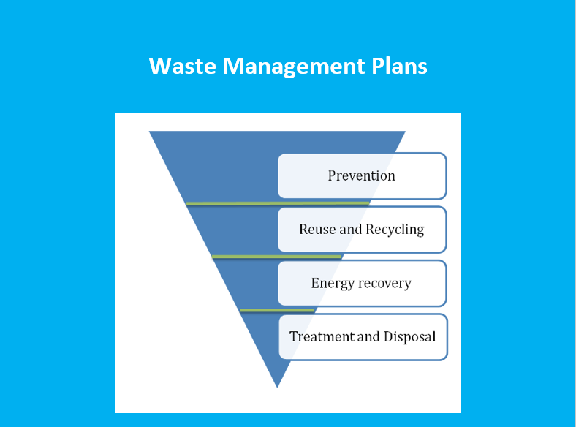

**Add any other take-away messages and key lessons for you:**



### Module 4.3. Chemicals and waste regulation: Experience from Norway and the international context

**Contents:**

* Chemical regulations and the Convention for the Protection of the Marine Environment of the North-East Atlantic (OSPAR Convention)
* Chemical regulations in Norway
* Other international initiatives on chemicals management
* Waste requirements in Norway and Best available techniques (BAT)
* Inventory and Reporting

**Learning objectives**

* Become familiar with international laws, regulations and best practices relating to chemicals and waste management;
* Learn about experiences in Norway with regards to chemicals and waste regulations

**OSPAR Regulatory regime on Chemicals**

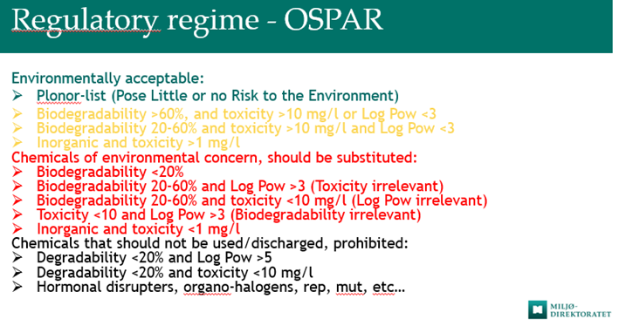

**Key messages**

* OSPAR categorizes chemicals into four categories: Environmentally acceptable (green), Chemicals that pose little or no environmental risk (yellow), of environmental concern (red) and prohibited (black).
* It is important to identify chemicals for substitution and replace chemicals of environmental concern.
* Both environmental and public health risks should be considered when examining chemicals.
* There are a number of international initiatives and Conventions that provide guidance and regulations on how chemicals and hazardous waste should be managed, transported, treated and disposed. These include the Basel, Rotterdam and Stockholm Conventions. The Basel Convention regulates international transportation of waste.
* Norway is guided by European Regulations and Best Available Technologies (BAT)-reference documents with regards to chemicals and waste, as well as its own national laws and regulations, including the Pollution Act, which calls for all activities causing pollution or risk of causing pollution to require permits.
* It is important for companies treating hazardous waste to have expertise and economic security to ensure proper treatment of waste in case of bankruptcy or cessation of company.

**Add any other take-away messages and key lessons for you:**



### Final Group Exercise: Action Planning

|  |  |
| --- | --- |
|  | Consider all the institutional / individual capacity challenges your team has identified since the start of the training. IDENTIFY additional challenges based on what you have learned and the new course materials presented thus far.  PRIORITIZE the top three CHALLENGES.  Discuss OPPORTUNITIES, CURRENT EFFORTS or ENTRY POINTS for addressing these top 3 challenges.  IDENTIFY GAPS OR ADDITIONAL ACTIONS that should be taken to address these challenges.  IDENTIFY WHO / WHICH MINISTRY/AGENCY/DEPARTMENT should take the lead for each additional action identified.  RECORD your discussions on a flipchart or in a powerpoint for presenting to the whole group.  You will have about 40-45 minutes to complete this exercise. Identify a rapporteur from your team. Only your top 3 challenges should be presented. |
|  |
|  |
|  |
|  |

**Action planning template**

| **Capacity Challenges and Gaps in chemicals and waste management within the oil and gas sector** | **Current Efforts / Opportunities / Entry Points to address the challenge** | **Additional actions to be taken** | **Leading Agency/Ministry** |
| --- | --- | --- | --- |
|
| Priority Challenge 1 |  |  |  |
| Priority Challenge 2 |  |  |  |
| Priority Challenge 3 |  |  |  |

## References

1. API (2012) Environmental Protection for Onshore Oil and Gas Production Operations and Leases. Accessed from <https://www.api.org/~/media/Files/Policy/Exploration/API_RP_51R.pdf>
2. Darko E (2014) Short guide summarising the oil and gas industry lifecycle for a non-technical audience. Overseas Development Institute, London. Accessed from <https://assets.publishing.service.gov.uk/media/57a089efed915d3cfd0004d4/Short_guide_summarising_the_oil_and_gas_industry_lifecycle-43.pdf>
3. IFC, IPIECA, and UNDP (2017) Mapping the Oil and Gas Industry to the Sustainable Development Goals. Accessed from <http://www.ipieca.org/resources/awareness-briefing/mapping-the-oil-and-gas-industry-to-the-sustainable-development-goals-an-atlas/>
4. IFC (2012) IFC Performance Standards on Environmental and Social Sustainability. Accessed from <https://www.ifc.org/wps/wcm/connect/c8f524004a73daeca09afdf998895a12/IFC_Performance_Standards.pdf?MOD=AJPERES>
5. IFC (2007) Environmental, Health and Safety General Guidelines. Accessed from <https://www.ifc.org/wps/wcm/connect/554e8d80488658e4b76af76a6515bb18/Final+-+General+EHS+Guidelines.pdf?MOD=AJPERES>
6. IFC (2015) Environmental, Health, And Safety Guidelines For Offshore Oil And Gas Development. Accessed from <https://www.ifc.org/wps/wcm/connect/f3a7f38048cb251ea609b76bcf395ce1/FINAL_Jun+2015_Offshore+Oil+and+Gas_EHS+Guideline.pdf?MOD=AJPERES>
7. IPCC (2012). Managing the Risks of Extreme Events and Disasters to Advance Climate Change Adaptation. A Special Report of Working Groups I and II of the Intergovernmental Panel on Climate Change. Cambridge University Press, Cambridge, UK, and New York, NY, USA, pp. 1-19. https://wg1.ipcc.ch/srex/downloads/SREX-All_FINAL.pdf
8. IPCC (2012). Summary for Policymakers. In: Managing the Risks of Extreme Events and Disasters to Advance Climate Change Adaptation. Cambridge University Press, Cambridge, UK, and New York, NY, USA. https://wg1.ipcc.ch/srex/SREX-SPM_FINAL.pdf
9. IPIECA (2015) Response strategy development using net environmental benefit analysis (NEBA): Good practice guidelines for incident management and emergency response personnel Accessed from <http://www.ipieca.org/resources/good-practice/response-strategy-development-using-net-environmental-benefit-analysis-neba/>
10. IPIECA (2012) Sensitivity mapping for oil spill response: Good practice guidelines for incident management and emergency response personnel Accessed from <http://www.ipieca.org/resources/good-practice/sensitivity-mapping-for-oil-spill-response/>
11. IUCN (2009). Environmental guidance note for disaster risk reduction. https://www.iucn.org/sites/dev/files/content/documents/2013_iucn_bookv2.pdf
12. Joint E & P Forum / UNEP (1997) Environmental Management in Oil and Gas Exploration and Production. Accessed from <https://wedocs.unep.org/bitstream/handle/20.500.11822/8275/-Environmental%20Management%20in%20Oil%20&%20Gas%20Exploration%20&%20Production-19972123.pdf?sequence=2&isAllowed=y>
13. Laurance et al (2015) Reducing the Global Environmental Impacts of Rapid Infrastructure Expansion. Accessed from <https://www.sciencedirect.com/science/article/pii/S0960982215002195>
14. Liu et al (2014) Assessing Oil Spill Risk in the Chinese Bohai Sea: A Case Study for both Ship and Platform related Oil Spills. Accessed from https://www.sciencedirect.com/science/article/pii/S0964569114002671
15. NOAA (2002) Environmental Sensitivity Index Guidelines. Accessed from https://response.restoration.noaa.gov/sites/default/files/ESI_Guidelines.pdf
16. Norwegian Petroleum Directorate (2013) Environmental And Climate Considerations in the Norwegian Petroleum Sector. Accessed from <http://www.npd.no/global/engelsk/3-publications/facts/facts2013/figures/chapter-09/chapter-9.pdf>
17. OECD (2007) Monitoring (Environmental). Accessed from https://stats.oecd.org/glossary/detail.asp?ID=1684
18. PEDRR. (2010). Demonstrating the role of ecosystem-based management for disaster risk reduction. <https://www.preventionweb.net/english/hyogo/gar/2011/en/bgdocs/PEDRR_2010.pdf>
19. Schneider et al. (2011) Achieving Conservation when Opportunity Costs are High: Optimizing Reserve Design in Alberta’s Oil Sands Region. Accessed from https://journals.plos.org/plosone/article?id=10.1371/journal.pone.0023254
20. STRONGER (2017) 2017 Guidelines Accessed from https://www.strongerinc.org/guidelines/
21. UNEP (2004) Environmental Impact Assessment and Strategic Environmental Assessment. Towards an Integrated Approach. Accessed from <https://unep.ch/etb/publications/EnvImpAss/textONUBr.pdf>
22. UNEP (2011) Environmental Assessment of Ogoniland. Accessed from <https://postconflict.unep.ch/publications/OEA/UNEP_OEA.pdf>
23. UNEP-WCMC (2018) Assessing Environmental Impacts - A Global Review of Legislation. Accessed from <https://www.unep-wcmc.org/resources-and-data/assessing-environmental-impacts--a-global-review-of-legislation>
24. UNISDR (2016). Report of the open-ended intergovernmental expert working group on indicators and terminology relating to disaster risk reduction. <https://www.preventionweb.net/files/50683_oiewgreportenglish.pdf>
25. World Bank (2013) Extracting Lessons on Gender in the Oil and Gas Sector. Accessed from <http://documents.worldbank.org/curated/en/266311468161347063/pdf/798940NWP0280E0Box0379795B00PUBLIC0.pdf>

**Glossary for Learning Game**

|  |  |
| --- | --- |
| **Words** | **Meaning** |
| COSHH | Control of Substances Hazardous to Health |
| Different types of waste treatment and disposal options | * Land filling * Land farming * Thermal technologies * Slurry injections |
| Harmful substances | Substances cause adverse effect due to amount of discharge, concentration and mode of discharge |
| Hazardous substances | Substance that may cause adverse effects due to toxicity, potential for bioaccumulation and biodegradation |
| Inspections and Audits | Carried out to ensure operator complies with laws, regulations, permits and environmental management system |
| Main stages of the oil and gas value chain | * Upstream * Midstream * downstream |
| MSDS | Material Safety Data Sheet |
| PPE | Personal Protective Equipment. |
| Produced water | Generated from the reservoir together with oil and gas |
| Purpose of using drilling fluids (during drilling) | Helps remove drilling fluids, control of formation pressure, and cooling of drill bit |
| Stages of the upstream oil and gas sector | * Seismic * Drilling exploration * Production/oil&gas recovery * Decommissioning |
| Sustainable development goals relevant to the oil and gas sector | * Goal 1- eliminate poverty * Goal 5- gender * Goal 6- water * Goal 7- infrastructure * Goal 13- climate change |
| Types of chemicals used in the oil and gas sector | * Drilling chemicals * Cementing chemicals * Cleaning and well treatment * Production chemicals |
| Waste | Any substance or object which the holder discards or intends to discard |